Table of Contents

1.0 Introduction 3

1.1 Company Background 3

1.2 Current Problem Facing 3

1.3 ERP General Functionalities 4

1.4 Reasons of ERP deployment for Spritzer 4

2.0 Literature Review 5

2.1 Business Nature 5

2.2 ERP Overview 6

2.3 ERP Project Lifecycle 6

2.4 ERP Methodology 11

2.5 Factors of ERP Success and Failure 13

2.5.1 ERP Success 13

2.5.2 ERP Failure 14

3.0 Methodology 15

3.1 Overview Implementation (Sage x3) 15

3.1.1 ERP IMPLEMENTATION STAGES 16

3.2 Procedure for P2P and O2C 18

3.2.1 Current Business Process 18

3.3 Business process after BPR 20

3.4 Reconfiguration & Setup 26

3.4.1 Master data of Company details 26

3.4.2 Company & Site 26

3.4.2 Business Partner (BPs) 27

3.4.3 Product List by Category & Code 31

4.0 Result & Analysis 35

4.1 GQT Development 35

4.2 P2P 37

4.2.1 Problem Statement and Analysis 37

4.2.2 Requester Analysis 37

4.2.3 Product Analysis 39

4.2.4 Supplier Analysis 40

**4.3 O2C** 42

4.3.1 O2C Overview (SO - DO - SIN) 42

4.3.2 Product Analysis 43

4.3.3 Customer Analysis 44

4.3.4 Problem Statement and Analysis 45

4.4 Inventory Management 46

4.5 Income Statement 50

4.5.1 Revenue, COS, OPEX 50

4.5.2 Comparison between Revenue, COS, Opex with Invoices 51

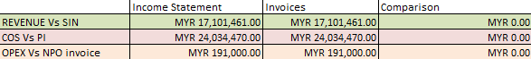 51

4.6 Balance Sheet 52

4.6.1 Trade Receivables, Trade Payables, Other Payables 52

4.7 Aging Report 54

4.7.1 Customer Aging 54

4.7.2 Supplier Aging 55

4.7.3 Other Payable Aging 56

5.0 Conclusion 58

5.1 Pre- and Post- Business Process Reengineering 58

5.2 ERP Implementation Success 59

5.4 Recommendations 61

6.0 References 63

7.0 Appendices 66

# 1.0 Introduction

## 1.1 Company Background

Spritzer Berhad has been Malaysia’s leading natural water brand since 1989, known for its focus on quality, sustainability, and innovation. In 1989, they built their first bottling plant in Taiping. They source natural water from underground water in Taiping where it naturally filters through rock layers for over 15 years. In 1994, they relocated to a larger facility and became the number 1 natural mineral water brand in 2002.

Led by CEO Kenny Lim, Spritzer operates through 8 subsidiaries focusing on manufacturing and distribution. Its sustainability efforts include eco-friendly packaging using 35% less plastic and more plant-based materials. Holding over 40% market share, Spritzer earned 590 million revenue in 2024 (Spritzer, 2024). Additionally, they are a founding member of the Malaysia Recycling Alliance (MAREA), Spritzer also supports community initiatives like blood donation drives.

Hence, their value is driven by sustainability and ensuring high quality natural mineral water to end consumers in local and international markets through subsidiaries and various distributors (8) as they are the first Malaysia’s brand to receive IS0 9003 Quality certificate (Spritzer, 2024).

## 1.2 Current Problem Facing

**Inventory Inaccuracy**

One major issue is inventory inaccuracy, often caused by miscounts, data errors, or delays in updating records. For a company like Spritzer, which manages large volumes of raw materials like PET preforms and bottle caps, mismatch between system records and actual stock previously disrupted production.

**Demand Forecasting Difficulties**

Another challenge is demand forecasting such as shifts in consumer behaviour, weather, or economic conditions make accurate forecasting difficult. Spritzer struggled during heatwave season as they experienced sudden demand surplus, facing bottlenecks.

**Technology Integration Gaps**

Even though technology streamlines processes, Spritzer struggles with disconnected systems like ERP, WMS, and MES, which slows information flow and disrupts planning. Spritzer addresses this by adopting Automated Storage and Retrieval System (ASRS) and 30+ Automated Guided Vehicle (AGV) at its Taiping plant. However, early challenges in syncing the ASRD with existing ERP/ WMS systems highlighted the importance of system integration.

## 1.3 ERP General Functionalities

Enterprise Resource Planning (ERP) systems integrate core business functions such as finance, human resource management, procurement, manufacturing, inventory, and supply chain into a unified platform, automating workflows and enhancing real-time visibility across departments. In manufacturing, ERP collects data from supply, demand scheduling and production, helping managers monitor resources and drive productivity while reducing costs. From a supply chain perspective, ERP centralizes procurement, inventory, logistics, and analytics, enabling automated purchasing, demand forecasting, and improved supplier coordination. Overall, ERP main functionality is aiding organizations with strategic decision-making by delivering timely, accurate intelligence across the enterprise (Khan et al, 2025).

## 1.4 Reasons of ERP deployment for Spritzer

1. **Improved Efficiency:** ERP automates repetitive tasks and integrates Spritzer’s business processes from generating reports to maintaining information, reducing manual workload and operational delays. This leads to faster workflow and removal of human errors.
2. **Real-time data and reporting:** Allows real-time tracking, ensuring data is updated and consistent across different departments that are accessible remotely. Leading to accurate decision making.
3. **Improved inventory and supply chain management:** ERP helps Spritzer track inventory and store employee information in a unified platform which helps faster data retrieval, manage procurement, increase demand forecasting accuracy, reduce the risk of overstocking.
4. **Cost Reduction:** By streamlining process and improving resource planning, ERP reduces administrative, inventory, and operational costs, resulting in improved cash flows. Moreover, Human Resource process is supported by ERP system auto generate payroll and various statement
5. **Enhanced collaboration:** Integration across departments from finance department to manufacturing and order management. Hence, improved internal communication and coordination, reducing information silos.

# 2.0 Literature Review

## 2.1 Business Nature

Spritzer’s product range includes distilled water, sparkling water, and fruit-flavored drinks under Tinge, Cactus. Desa and Summer. They perform forward and backward integration from sourcing natural water to bottling, packaging and distribution. Golden PET Industries and Pet Master are their subsidiary suppliers that produce plastic components for bottling. Their bottling process is fully automated, as they have adopted ASRS warehouse and AGV in Taiping to boost efficient and automating processes.

Chuan Sin Cactus distributes their products to markets in Malaysia and Singapore, while Spritzer Trading Ltd distributes to China markets. Spritzers exports globally to international markets and it’s positioned itself as a sustainability-driven company with its own protected water facility.Lastly,their products reach end consumers through retail outlets such as Lotus, Jaya Grocer and online platforms (Nestle, 2024).

## 2.2 ERP Overview

Enterprise Resource Planning (ERP) could be described as a backbone of business intelligence that acts as a unified software system designed to integrate and manage core business processes in real-time. ERP connects functions such as finance, procurement, inventory, production, human resources, and supply chain management into a centralized system, providing a single source of truth across departments. This integration facilitates data consistency, reduces manual task, cost reduction and enhanced collaboration.Modern cloud ERP supports cloud-based deployment, real-time analytics, and mobile access. This allows scalability, especially for manufacturing retail and logistics (Ullah, 2018).

## 2.3 ERP Project Lifecycle

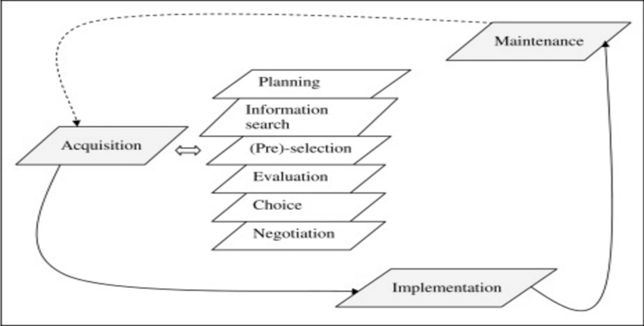

Figure 1: ERP Lifecycle

**Acquisition process**

The acquisition process involves assessing and choosing suitable suppliers, as well as finalizing procurement agreements for the necessary products and services. It encompasses identifying, sourcing, preparing, and sending communications like Request for Proposals (RFPs) and Request for Quotation (RFQs), reviewing supplier submissions, and negotiating contractual terms with selected vendors. An comprehensive acquisition process framework consists of 6 stages (Vervilled & Hallington, 2003, as cited Bhatti, 2014)-

1. **Planning:** Defining operation needs and clear objectives for what it wants to achieve through the acquisition. This includes determining the scope of the project, setting budget, outlining timeline and stakeholders involved from finance, procurement, IT, and end-users as overall strategy.
2. **Information Search:** Gathering information about available vendors and system to fulfill its business objectives. This involves conducting market research to understand the range of solutions offered, reviewing vendor websites, consulting product documentation and reaching out to consultants for recommendations and insights about available vendors.
3. **Selection or pre-selection:** Filtering our few suitable vendors based on different criterias and essential functionality to create a list of shortlisted vendors who meet minimum business and technical requirements. This stage may involve informal discussion and reviewing sample materials for validation.
4. **Evaluation:**Conducting detailed assessment from quotations provided by shortlisted vendors. The acquisition team defines specific evaluation criteria, such as functionality, packages offered, scalability, and total cost ownership (TCO) by requesting Request for Quotation (RFQs). The quotation should include comprehensive financial information and software applications.
5. **Choice**: Making final decision on selecting a vendor, this involves reviewing all findings, including technical scores, user feedback, cost analysis amd long-term considerations. The acquisition team presents its recommendation to senior management for final approval. Once approved, prepare for contractual agreement.
6. **Negotiation:** Finalizing terms and conditions under which the services will be procured. The organization and selected vendor conduct meetings to discuss necessary terms and clarify contracts such as licensing, pricing, payment terms, implementation schedules, and post-implementation support. The goal of this phase is to reach a mutually beneficial agreement, making way for implementation.

**Financial Module**

**Income Statement-** Shows company’s financial standing at a particular period. It entails an organization's asset, liabilities, and equity. This report is used by stakeholders such as employees, owners, investors, customers for decision-making and financial reporting.

**Balance Sheet-** Summarizes a company’s income, expenditure, and overall profit or loss. It reflects the financial performance of revenue generated and costs incurred during operations.

To conclude, ERP system automatically update these reports through real-time entries from sales, purchasing, and inventory (Barna, 2021).

**Type Of Implementation Cycle**

An implementation cycle refers to the step-by-step process involved in planning and deploying a system. While ERP systems follow a specific implementation cycle tailored to integrate core business functions, other types of software products such as Customer Relationship Management (CRM) systems, Supply Chain Management (SCM) tools, and Manufacturing Execution Systems (MES) also follow structured but distinct implementation frameworks.

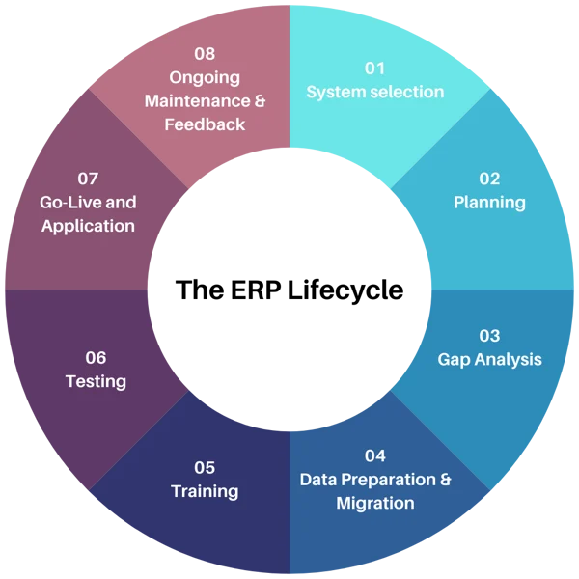

Figure 2: ERP Implementation Strategies

The implementation of an ERP system within a big organisation such as Spritzer requires a very well structured approach to ensure that it operates smoothly. For instance, each stage plays a significant role in ensuring that all operations run smoothly without any hiccups.

**1) System Selection:** The beginning involves evaluating a wide variety of ERP solutions to determine the system that would be most suitable for Spritzer’s needs and operations. Taking into consideration the fact that Spritzer relies on advanced automation technologies such as ASRS and AGV. The ERP system chosen has to be capable of supporting high levels of integration with warehouse and production management systems. (*ERP For Manufacturing: Now More Than Ever | SAP*, n.d.)

**2) Planning:** A detailed project roadmap is developed which outlines the ERP implementation scope, resource allocation and budget forecasting. Effective planning plays a huge role in aligning IT goals with operational strategies (*The 8 Stages of an ERP Implementation Life Cycle*, n.d.). For Spritzer, this can consist of aligning the ERP with sustainability goals , ensuring cross-functional collaboration, setting objectives for procurement as well as forecast automation. All of these must be taken into consideration when planning to improve the efficiency of Spritzer’s operations.

**3) Gap analysis:** During this phase,Spritzer conducts a performance evaluation of its legacy system which they previously used before such as WMS, manual spreadsheets and disconnected MES platforms in order to identify the weak points of such systems. After this, the ERP solution will be benchmarked against current workflows to identify any functional and efficiency gaps (Hassan et al., 2016) . This phase helps with uncovering the weaknesses and disparities in the procurement cycles, stock tracking accuracy as well as the demand forecasting precision which must be resolved through ERP customization.

**4) Data Preparation & Migration:** This involves cleaning,validating and importing master data such as suppliers and financials into the new ERP system (*ERP For Manufacturing: Now More Than Ever | SAP*, n.d.), There must be a strong emphasis on the accuracy and structure of the data as it is the foundation for a successful go-live. Spritzer’s data migration includes things such as stock levels, customer records , supplier records and financial entities which support the seamless transactional functions before it is deployed live.

**5) Training:** The staff must be trained thoroughly and extensively. This equips the staff with knowledge on how to properly utilise the ERP system (*The 8 Stages of an ERP Implementation Life Cycle*, n.d.). This includes simulations , real-time practice and role-based training modules to reduce resistance and build the confidence of the staff utilising the system.

**6) Testing:** Before going live, the ERP system must undergo a thorough functional and integration test. This includes user acceptance testing (Hassan et al., 2016). This testing phase must identify weaknesses in the security of the system, compatibility issues and performance bottlenecks. All this must be tested thoroughly to ensure that Spritzer’s operations do not suffer from any bottlenecks and remain uninterrupted during launch.

**7) Go-live and Application:** Once the tests have been done and validated , the ERP system will be launched live . This phase composes of real-time synchronization of all other operational modules as well as a phased cutover approach to reduce risk (*ERP For Manufacturing: Now More Than Ever | SAP*, n.d.). Once the ERP system has been launched live, Spritzer’s departments will begin managing procurement , order fulfilment , and stock replenishment with the new ERP system interface. This will significantly reduce the latency and errors.

**8) Ongoing maintenance & Feedback:** After a succesful launch, the new ERP system must be maintained and monitored thoroughly and frequently. This is done to ensure that frequent maintenance is being done. Feedback will also be taken from the users for constructive criticism in order to further improve the ERP system.

## 2.4 ERP Methodology

The ERP implementation methodology provides us with a structured roadmap for integrating Sage X3 into Spritzer Berhad’s business operations. This approach ensures us that each critical phase is carefully planned with every consideration in mind before executing. This ensures that the deployment is successful and is efficient in the long run.

(*Oracle Netsuite Cloud ERP Solution Overview*, n.d.). The following ten stages summarize the methodology used to implement the ERP system.   
 **1. Pre-evaluation screening:** This stage begins with an assessment of the organizational needs of Spritzer. For instance, supply chain inefficiencies , data silos , and disconnected systems.

**2. Package Evaluation:** After defining business requirements , we evaluated various ERP solutions and ended up choosing Sage X3 was selected for its ability to integrate with automated technologies such as ASRS and AGV’s. This offers the ability to view data in real-time across Spritzer’s operations.  
 **3. Project Planning Phase:** A detailed implementation roadmap is created. This includes factors such as resource planning, budgeting, stakeholder roles and a timeline of the project. Key performance indicators (KPI) were established as a way to measure the progress and effectiveness throughout the phase.

**4. Gap analysis:** We analysed the current systems of Spritzer. For instance, manual spreadsheets, WMS and identified functional gaps. Especially in inventory tracking and procurement processes. These gaps were compared to Sage X3’s capabilities to determine whether customization was needed.

**5. Reengineering:** Based on the findings from our gap analysis. We have redesigned the existing workflows. For instance, we optimized the procure-to-pay (P2P) and order to cash (O2C) cycles to eliminate manual tasks and reduce redundancies.   
 **6. Customization:** We configured the ERP system to match the operational requirements of Spritzer. Modules such as procurement, inventory, finance and warehouse integration were optimized and tailored to align with Spritzer’s automation strategy.

**7.Testing phase:** A thorough and comprehensive testing was conducted to ensure data integrity, system security and process accuracy . The User acceptance testing (UAT) helped us with identifying potential issues before launching it live in the go-live phase. This helped minimise operational risks.

**8. ERP deployment:** Once tested and validated, Sage X3 was deployed across all of the relevant departments in Spritzer. Real-time synchronization of inventory, finance and purchasing functions was in place. This is done for Spritzer to operate more efficiently and respond quickly to market demands.

**9. End-user Training:** Training programs were designed and taught to staff based on their roles and responsibilities. This included situations such as simulations and hands-on practice for the staff. This is done to ensure that all users have the knowledge,skills and confidence to navigate the newly implemented system.

**10. Post-implementation support:** Continuous support was provided after the go-live phase to further monitor the performance of the system , address technical issues and as well as to incorporate the feedback of the users. Frequent updates and maintenance ensured that the ERP system remained aligned with Spritzer’s evolving needs.

## 2.5 Factors of ERP Success and Failure

### 2.5.1 ERP Success

Firstly, one of the key factors is engaged management support. Leadership at Spritzer plays a very pivotal role in guiding the company’s strategic goals in developing clear long term objectives. Without strong leadership, ERP projects often suffer from a lack of authority and accountability which can ultimately lead to project failure (Bingi et al., 1999).

Secondly, user training and change management must be prioritized in order to minimise the resistance of existing employees and enhance the new system adoption (Altamony, 2016). Customised and tailored training programs enable employees to gain confidence in using the newly implemented system. This is especially helpful for those working with warehouse automation systems such as ASRS. Effective change management and comprehensive training are critical for overcoming employee resistance and ensuring smooth ERP adoption. (Al-Mashari et al., 2002).

Thirdly, clear project planning and defined KPI’s helped the team to track progress and stay on schedule. The usage of performance metrics allowed Spritzer to monitor the implementation of the new ERP system and address the issues proactively. The adoption of performance metrics enables Spritzer to monitor the ERP system in real time. By adopting performance indicators, Spritzer can monitor the ERP system in real-time, identify bottlenecks before they occur, and implement solutions.A structured project management and measurable objectives are central to successful ERP rollouts (Nah et al., 2001).

Finally, ensuring the implementation team is experienced and knowledgeable about the ERP Process is vital to achieving a smooth and efficient rollout. With an experienced team, having the technical expertise and a very thorough understanding of the business processes allows them to anticipate any potential issues that may occur in the future. With an expertise team, it ensures that the standard is held in terms of ability and competence. For instance, during critical phases like data migration or user acceptance testing (UAT). It is crucial that the implementation team is experienced and ready to handle any risks of delays.

This ensures that Spritzer is able to minimize disruptions and ensure that the ERP system is reliable. Having a skilled and competent implementation team significantly minimizes disruptions and ensures the ERP system remains reliable (Finney & Corbett, 2007).

### 2.5.2 ERP Failure

On the other hand, there are various failure factors that can derail ERP implementation if they are not properly addressed. The first one is an inadequate requirement analysis , it can lead to mismatched system functionalities. For instance, if Spritzer fails to align Sage X3’s modules with its procurement or inventory needs, it can have a detrimental impact on their operations and cause it to be inefficient. Poorly defined requirements and misalignment between system design and business processes are common causes of ERP project failure (Niranjan, 2025).

The second risk is the lack of user involvement during early stages. This is because ERP projects that do not have any end-user feedback in place will often face adoption issues after the go-live phase due to no feedback to improve. Poor data quality and migration issues can compromise the integrity and security of the system. For example, transferring inaccurate or outdated data from Spritzer’s legacy system may lead to false reports which will then lead to bad decision making. Insufficient user participation is a challenge that undermines ERP implementation success (Al-Mashari et al., 2002)

The third risk is poor data quality and migration issues. These issues can compromise the integrity, accuracy and overall security of the ERP system. ERP systems rely on data that is clean,accurate and complete in order to function effectively at its best. When inaccurate, duplicated or outdated data flows into the new ERP. It can have a detrimental effect as it can cause inaccurate reports, wrong inventory levels and misguided decision making. For instance, the system might generate inaccurate purchase orders or misleading inventory reports. Poor data quality and migration difficulties often undermine the realization of ERP benefits, leading to costly inefficiencies (Venkatesh, 2010).

Another notable factor is insufficient change management. ERP implementation is not only a technological shift but also a drastic organizational change. It requires employees to adapt to the new system and processes. Without a structured change management plan which includes factors such as communication strategies and specialised training, new users may resist the system and revert back to old practices.Without a structured change management plan, which includes communication strategies and specialised training, new users may resist the system and revert back to old practices. Change management failures have been a root cause in many ERP failures (Gupta, 2000).

# 3.0 Methodology

## 3.1 Overview Implementation (Sage x3)

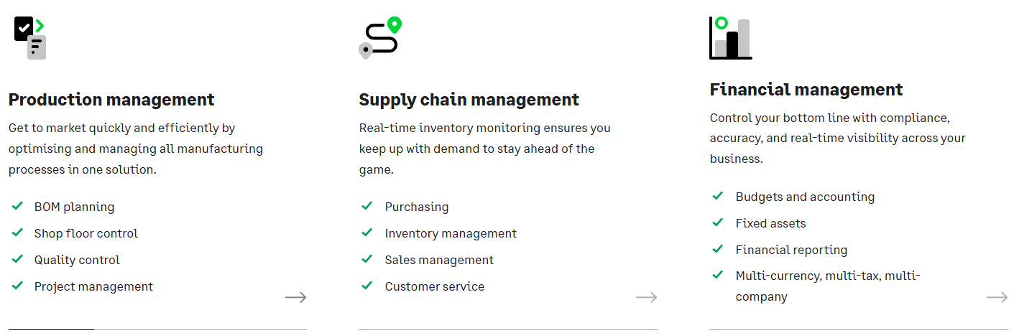

*Figures 3.1 Overview of ERP system (Sage X3)*

Sage X3 is an ERP system that brings together and controls important company tasks (Sage Group plc, n.d.).

• Financial management includes accounting, budgeting, and reporting.

• Business Intelligence (BI): Offers data insights and reporting tools.

• Manages manufacturing procedures and planning.

• Manage inventory, stock movement, and warehousing operations.

• Oversees supply chain operations, including logistics, order management, and delivery, to ensure a smooth transition from supplier to customer.

• CRM: Handles customer connections, interactions, and sales leads.

• Sales: Streamlines the sales process.

Sage X3 is well-known for its flexibility, scalability, and ability to combine numerous business operations into a single system, resulting in increased productivity and decision-making. Its purpose is to help modernise business processes across a company's value chain by recording transactions and information in a more timely and systematic manner using a flexible data model. SAGE's implementation strategy contains six main phases (Sage Group plc, n.d.).

Additionally, Sage X3 implementation guides break down a rollout into six steps: Discover, Design, Configure, Test, Deploy, and Optimise. However, they also recommend that teams incorporate quick, two-week "micro-sprints" into each phase to identify and address data-migration and integration errors before go-live.

## 3.1.1 ERP IMPLEMENTATION STAGES

*Figure 3.1.1 ERP implementation Stage (Iusov, n.d.)*

**1. Plan (Discovery and Planning)**

Analysts then transform those requirements into target process mappings and data migration rules, while conducting a gap analysis between "as-is" activities and vanilla Sage X3 capabilities. Companies that involve superusers in design workshops guarantee that the configurations they chose are both useful and closely matched with day-to-day reality.

**3. Development (Configuration & Build)**

Consultants are presently configuring parameters, coding light custom extensions, and running repeated mock loading of cleaned data. Greytrix's Sage X3 roadmap recognizes this stage as the time to develop training content and integration hooks to ensure that everything works together before formal test cycles begin.

**4. Testing**

Every material-flow scenario is validated by unit, integration, and user acceptability tests, which include stress-test performance at high loads. Sage advocates short, repeated sprints to ensure that faults are identified early and resolved before cut-over.

**5. Deployment**

After configuration, migration, and testing are completed, the team performs a staggered cut-over, transferring static masters first and live transactional data soon before go-live, to limit operational impact. Real-time dashboards monitor stability during the hyper-care window.

**6. Support and Optimisation**

Post-go-live, continuous-improvement cycles maintain Sage X3 adjusted to changing company needs: Help-desk assistance, minor release updates, and KPI evaluations flow back into future optimisation sprints, according to industry studies that relate continuous ERP value realization.

## 3.2 Procedure for P2P and O2C

### 3.2.1 Current Business Process

Spritzer produces and distributes bottled water (distilled, sparkling, and flavoured). Raw received or issued; high-velocity SKUs are counted often (Lewczuk et al., 2021).

#### 3.2.3 Business Process Re-Engineering

BPR assists S9SZ by speeding up the full process from buying to selling, getting rid of re-keying and delays, and showing every movement in real time. In P2P, MRP-driven PR/PO, dock scanning to auto-post GRN (with QA holds), and rigorous 3-way matching all help decrease mistakes, speed up approvals, and keep GRNI under control while making supplier OTIF better. Better connection between ERP and WMS (and MES if utilised) on the shop floor makes it easier to handle backflush problems, get correct yields, follow FEFO rules for drinks, and respond more quickly to spikes in demand. In O2C, ATP/CTP promising, wave selection, and auto-invoicing after shipment all help fill rate and minimise backorders. Credit restrictions and automated cash application, on the other hand, lower DSO. Finance gets clean tie-outs (PIN-GRN-PO; SIN-Revenue), live dashboards, and a stronger audit trail. The end result for S9SZ is faster cycle times, more accuracy, reduced costs to serve, and better control over working capital (Sage Group plc, n.d.).

#### 3.2.3.1 Purchase-To-Pay (P2P) process flow

*Figures 3.2.3.1 Process for P2P flow*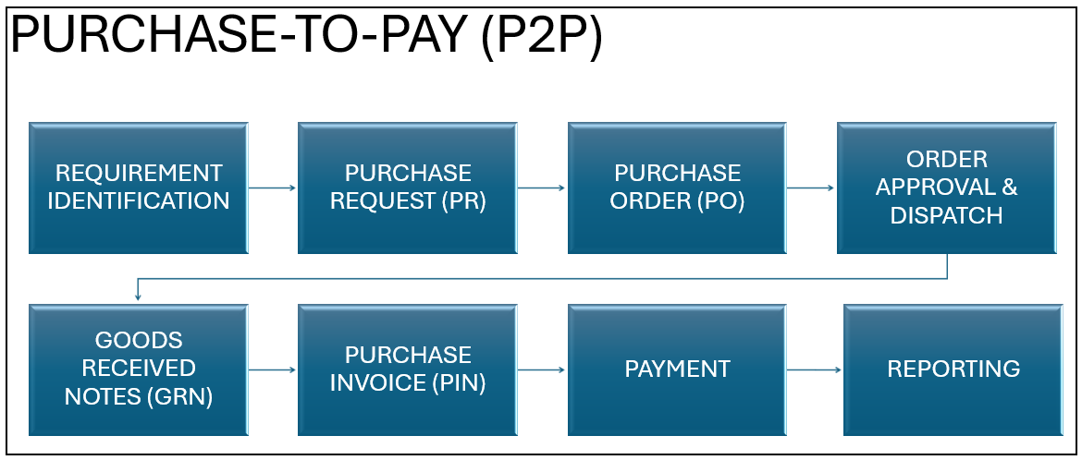

First, the P2P process begins with determining the procurement requirements for S9SZ, which comprise materials used in production such as Apple Flavourings, Citric Acid, and others. Once the procurement team has identified the necessary materials, they will generate a Purchase Request (PR) that includes information such as product codes, descriptions, quantities, and suppliers.

Second, the PR is then used to produce a Purchase Order (PO). The PO's approval may include all of the station's financial and operational staff. The authorised PO is subsequently given to suppliers who will complete the orders made by customers.

Third, the supplier provides a GRN indicating delivery once the requested products arrive at S9SZ's facilities. Before approving the GRN, the procurement team verifies that the products delivered correspond to the PO in terms of quantity and quality.

Forth, the supplier then delivers a Purchase Invoice (PIN) to the company's finance staff, who cross-check it against preceding documentation (PR, PO, GRN). Following confirmation of correctness, the finance staff makes the payment. Finally, the transaction is put into the Accounts Payable account and documented in the S9SZ ledger account.

#### 3.2.3.2 Order-To-Cash process

*Figures 3.2.3.2 Process for O2C flow*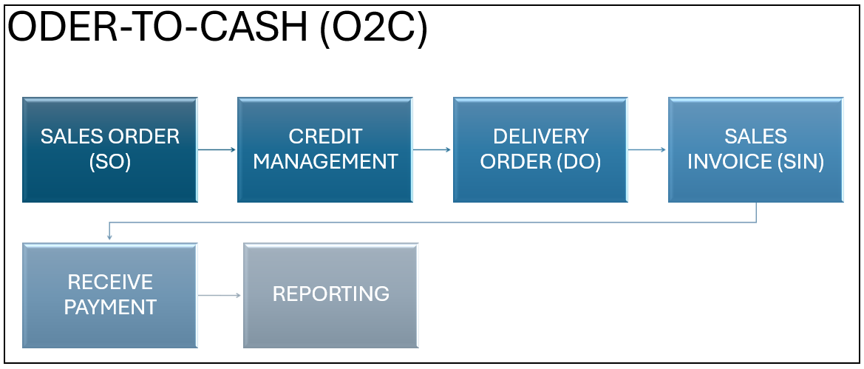

The O2C process at S9SZ would commence after a customer has placed an order. A Sales Order (SO) would be generated with product descriptions, prices, and customer information. The SO would be sent to other departments to process orders, such as stock inspections and production.

Once credit approval is achieved, the orders will be produced and sent out. A Delivery Order (DO) would be issued to guarantee that clients get the items they bought. When clients accept the DO, a Sales Invoice (SIN) is generated, which includes payment and product information.

If clients are unable to pay quickly, the transaction will be sent to the S9SZ accounts receivable system. It will keep and monitor outstanding balances, hence improving cash flow via ageing analysis. For example, when due dates approach, the accounts receivable staff must follow up with clients to ensure payment. After receiving the payments, the amounts will be entered in the S9SZ general ledger for financial reporting.

These procedures might be modified at S9SZ to increase operational performance, reduce manual effort, and give improved accuracy and cost-effectiveness.

## 3.3 Business process after BPR

#### 3.3.1 Transactional process

The transactional process of S9SZ includes five product flows: Buy-only, Buy-Sell, Buy-Inventory-Use, Buy-Inventory-Sell, and Sell-Only

##### 3.3.1.1 BUY-ONLY

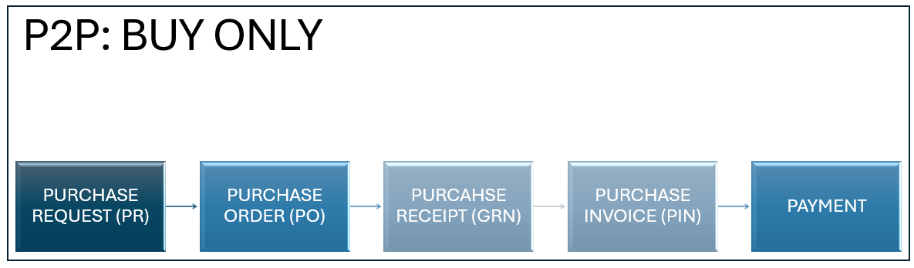

*Figures 3.3.1.1 Flow for Buy-Only*

Purchase Request (PR): A request for an item or service, including the quantity, need-by date, cost center or project, and permission.

Purchase Order (PO): The buyer sends a PO to the supplier containing the price, terms, and tax.

Receipt of Purchase (GRN / Service Entry): Check to see if you got the items or services. No inventory is made; the cost goes straight to the expense, asset, or project, and the GR/IR accrual is credited.

Purchase Invoice (PIN): AP executes either a 3-way (PO+Receipt+Invoice) or a 2-way (PO+Invoice for some services) transaction. It keeps track of Accounts Payable and clears GR/IR.

Payment: Pay according to the terms; the AP responsibility is cleared and the money is transferred.

With the buy-only method, the company only helps the consumer acquire the items. The goods flow straight from the supplier to the buyer, and the company never has legal ownership to them. It doesn't own or keep the items, hence its balance sheet doesn't show any inventory. Instead, it merely shows the pass-through payable/receivable (and maybe a modest handling or commission charge).

##### 3.3.1.2 Buy-Sell

*Figures 3.3.1.2 Flow for Buy-Sell*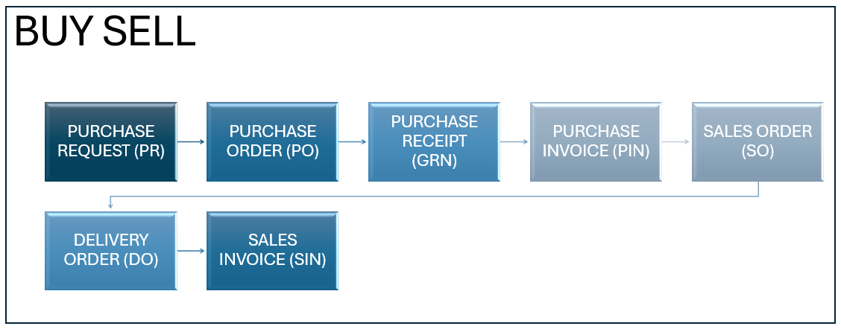

Purchase Request (PR): a request to buy things to restock.

Purchase Order (PO) → sent to the supplier.

Purchase Receipt (GRN): items received; inventory goes up (QA hold is optional); GR/IR accrual is posted.

Purchase Invoice (PIN): AP matches PO+GRN, and the AP responsibility is entered.

Sales Order (SO): made when a consumer places an order; the system holds available stock (ATP).

Delivery Order (DO): select, pack, and ship; inventory goes down.

Sales Invoice (SIN): revenue and accounts receivable are recorded, and cost of goods sold (COGS) is filed as an expenditure.

(Payments from suppliers and customers clear AP and AR, respectively.)

These are purchase-to-order (drop-ship) lines. The supplier delivers straight to your client, so you never have to have stock on hand, do put-away/picking, or value the SKU in your warehouse. In the ERP, they are marked as non-inventory or non-stocked products, so there is no stock ledger or cycle counts. Instead, MRP interprets the demand as a straight buy-to-order instead of restocking the warehouse.

##### 3.3.1.3 Buy-Inventory-Use

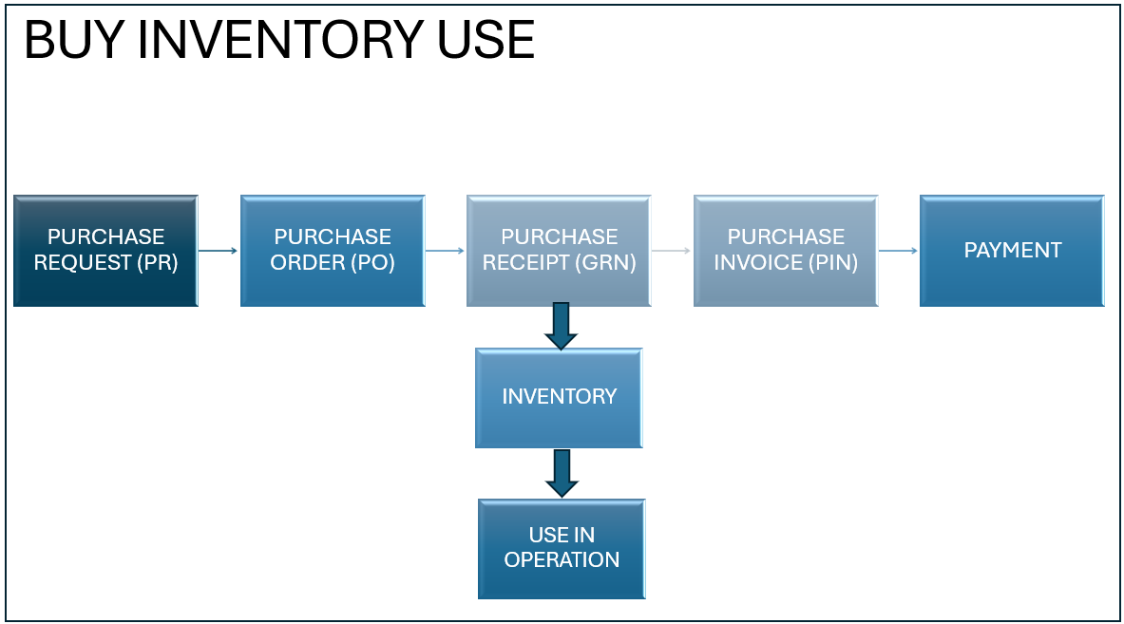

*Figures 3.3.1.3 Flow for* Buy-Inventory-Use

Purchase Request (PR): The user makes a PR with the item, quantity, and need-by date, and it is sent for approval.

Purchase Order (PO): Procurement turns an authorized PR into a PO and sends it to the supplier, making a promise.

Purchase Receipt (GRN): The goods arrive, and the person receiving them uploads the GRN (and optionally holds them for QA). On-hand amounts go up; GR/IR accrual is posted.

Inventory: Items are stowed away and held in stock as part of inventory.

Use in Operation: Materials are taken from inventory and put into the production, maintenance, or sales kit (inventory goes down, WIP/expense goes up).

Purchase Invoice (PIN): AP compares the supplier's invoice to the PO and GRN, recognizes the responsibility, and clears the GR/IR.

Payment: AP pays according to the agreements; responsibility is discharged, and cash is received.

In the Buy-Inventory-Use cycle, items are acquired from suppliers, kept as inventory, and consumed by the firm; they are not intended for sale to customers. As a result, they are designated as inventory objects for usage.

##### 3.3.1.4 Buy-Inventory-Sell

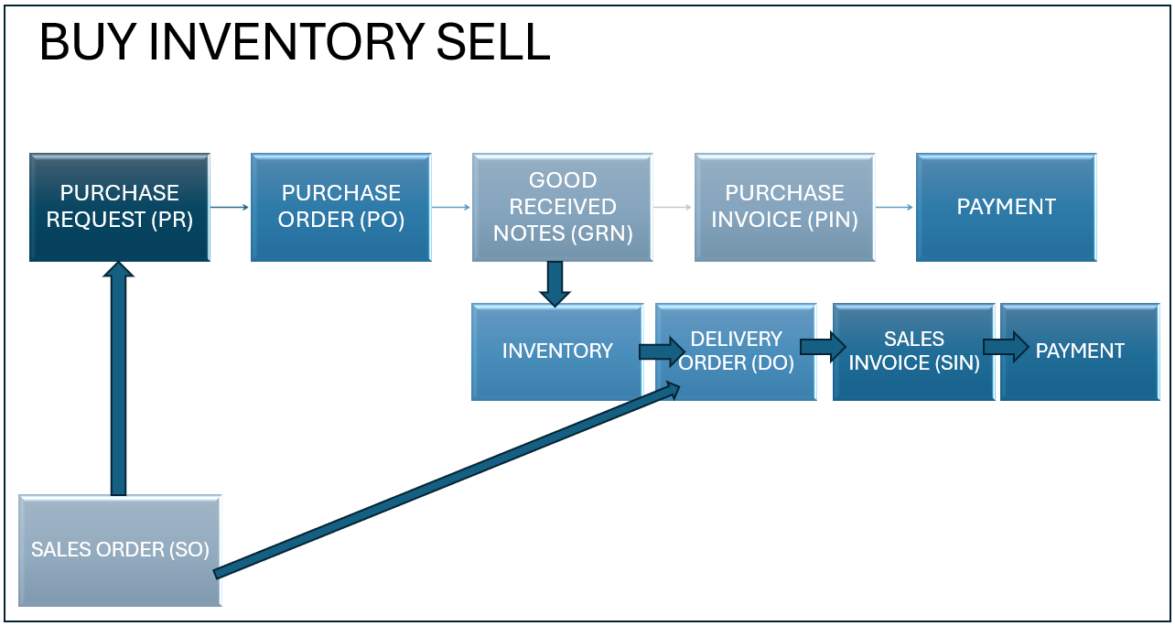

*Figures 3.3.1.4 Flow for* Buy-Inventory-Sell

Sales Order (SO): The customer places an order, and the system verifies the supply. In summary, the SO starts a Purchase Request (PR) that includes the item, quantity, and need-by date.

Purchase Request (PR) -> Purchase Order (PO): Procurement turns the PR into a PO and sends it to the supplier.

Goods Receipt (GRN): The supplier delivers, and the warehouse publishes the GRN. Inventory goes up; optional QA hold; GR/IR accrual is booked.

Purchase Invoice (PIN): Accounts payable compares the supplier's invoice to the PO and the GRN. The obligation is recorded and the GR/IR is cleared.

Payment to Supplier: AP pays according to the agreements.

Allocate/Pick/Ship (Delivery Order, DO): The stock is set aside for the SO, picked, packaged, and sent. The amount of stock goes down.

Sales Invoice (SIN): Revenue and accounts receivable are recorded, and the cost of goods sold (COGS) is documented as an expense or work in progress (WIP).

Customer Payment: AR was cleared when it was received

##### 3.3.1.5 Sell-Only

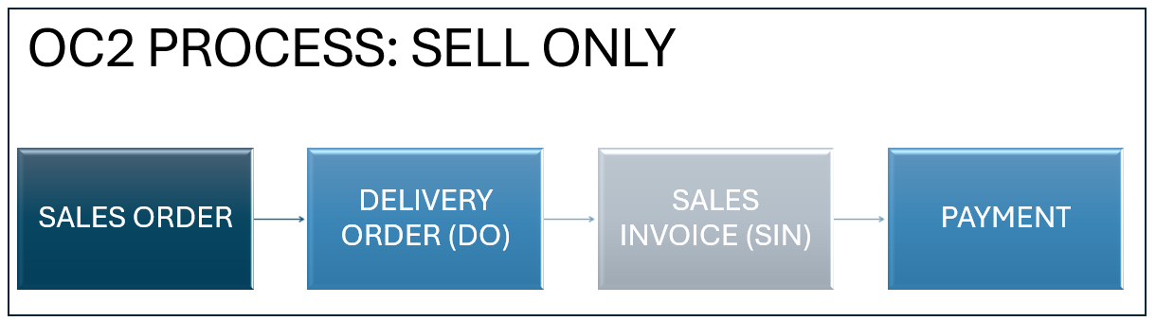

*Figures 3.3.1.5 Flow for Sell Only*

Sales Order (SO): Record a customer's order for services or goods that aren't in stock (prices, taxes, dates). No ATP or reserve of inventory.

Delivery Order (DO): Fulfilment/proof of delivery (e.g., service finished, license provided). Records quantity/hours; no stock movement or COGS from inventory.

Sales Invoice (SIN): Change DO (or SO directly) into an invoice, post AR and revenue, and add taxes or withholdings if necessary.

Payment: Get cash and clear AR; if necessary, take care of write-offs and credit notes.

## 3.4 Reconfiguration & Setup

### 3.4.1 Master data of Company details

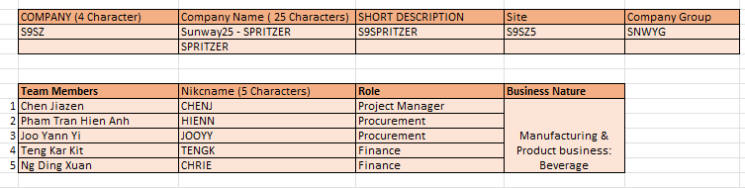

Figure 3.4.1 : Master Data of Company Details

The above figure shows the Spritzer’s (S9SZ) information, including name, site, company group and employees details and their roles.

### 3.4.2 Company & Site

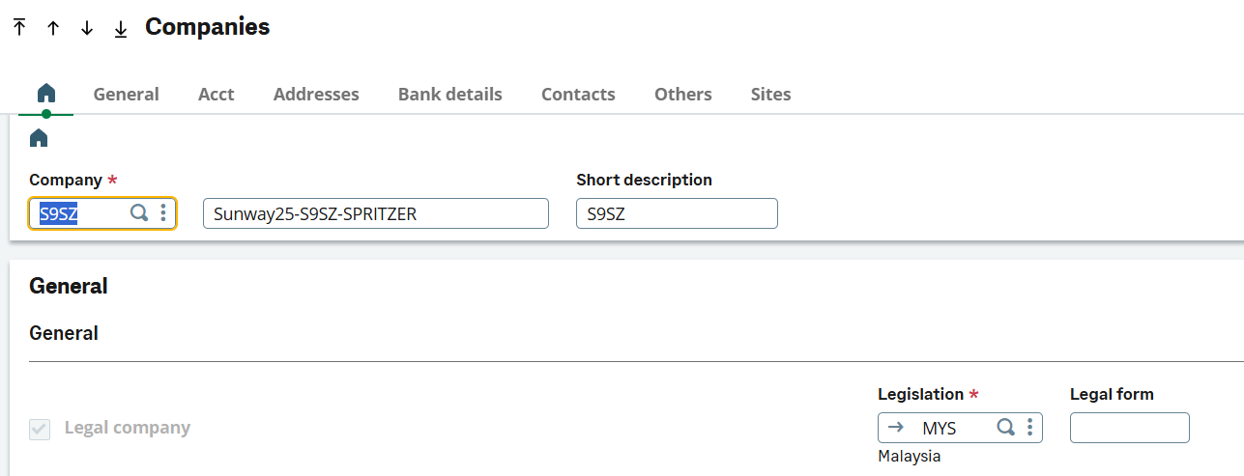

Figure 3.4.2 : Setup Company Code

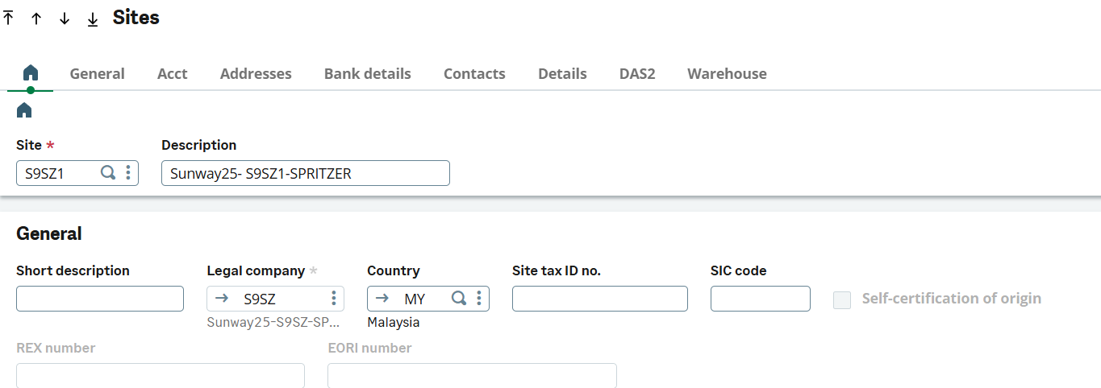

Figure 3.4.3 : Setup Company Site

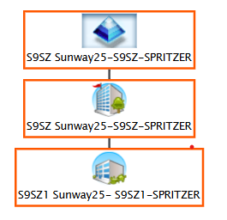

Figure 3.4.4: Site Pyramid

* The above figure shows the structure of Spritzer primary site S9SZ- Spritzer linking with its secondary site S9SZ1- Spritzer, establishing a relationship between company and site.

### 3.4.2 Business Partner (BPs)

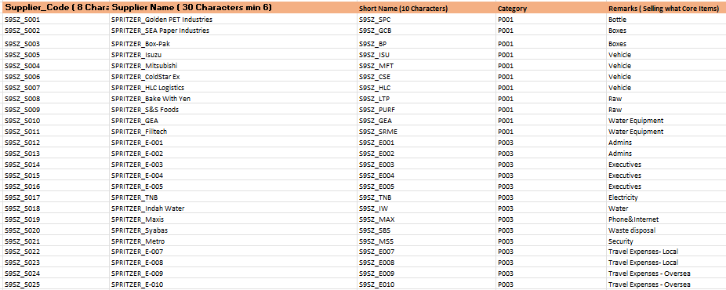

Figure 3.4.5 : Suppliers List

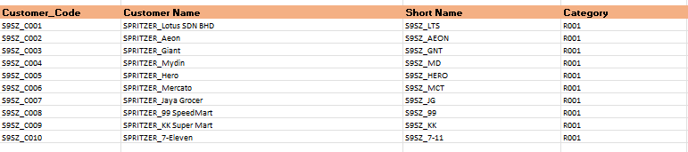

Figure 3.4.6: Customer List

* The above 3.4.5 figure shows the suppliers list of Spritzer (trade payables & creditors) and figure 3.4.6 shows the customers list (trade receivable). In the suppliers list, the code P001 is categorized for “trade payables” and code P002 & P003 is categorized for “other creditors” such as electricity or water providers. The purpose of the master data sheet is to support more efficient data retrieval and ensure better data management.

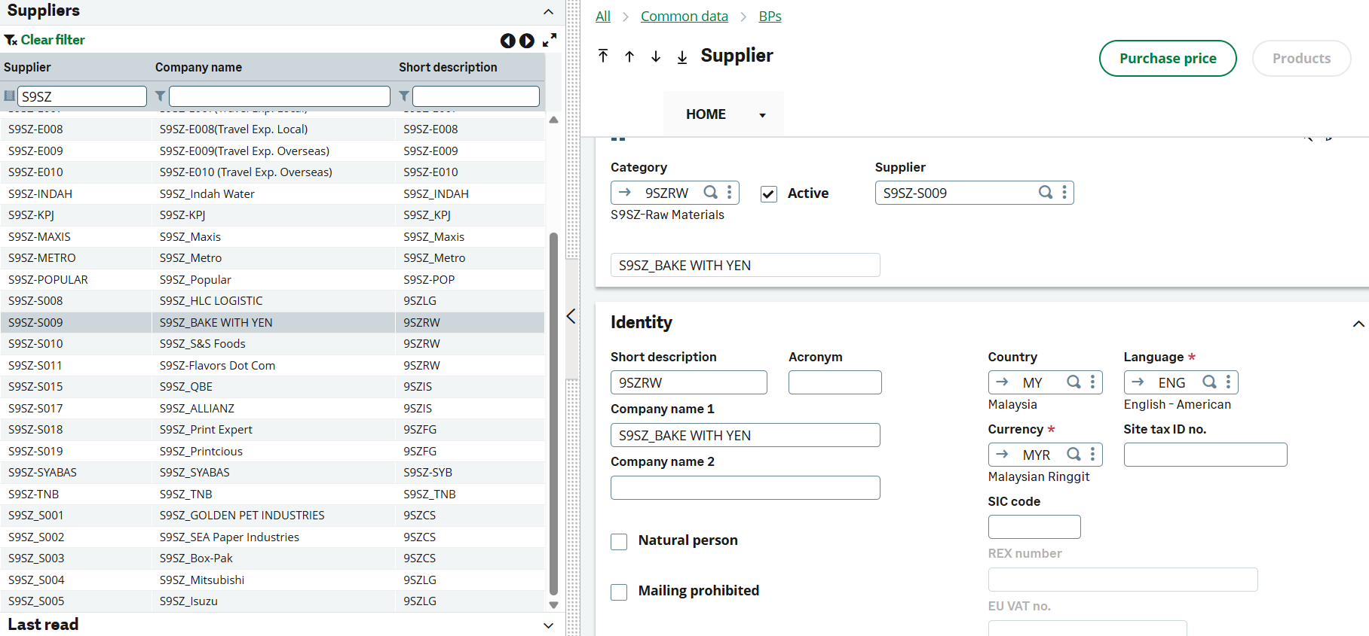

Figure 3.4.7: Example for Supplier Setup

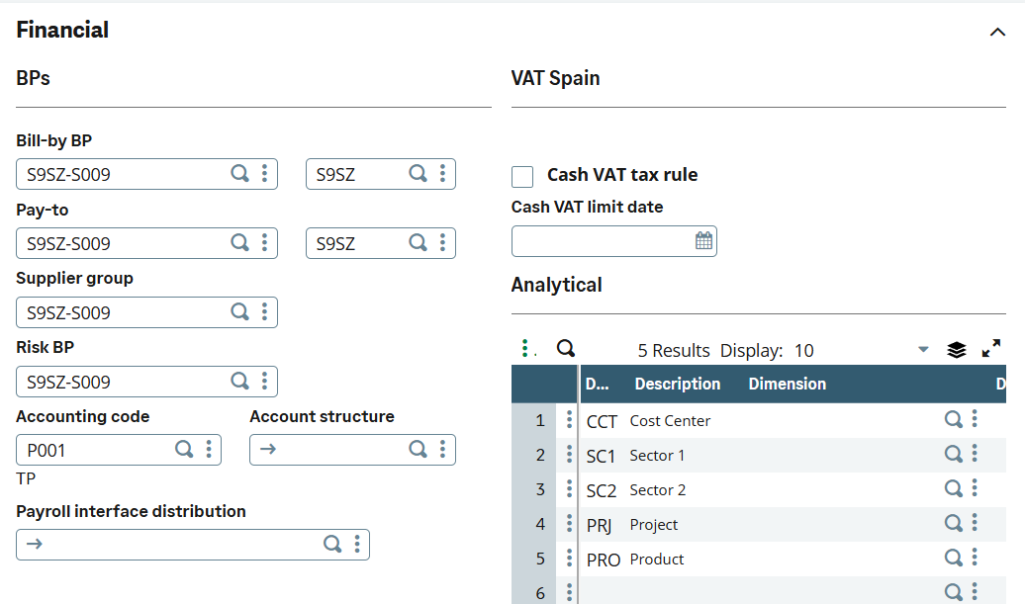

Figure 3.4.8: Example for Supplier Setup with Accounting Code

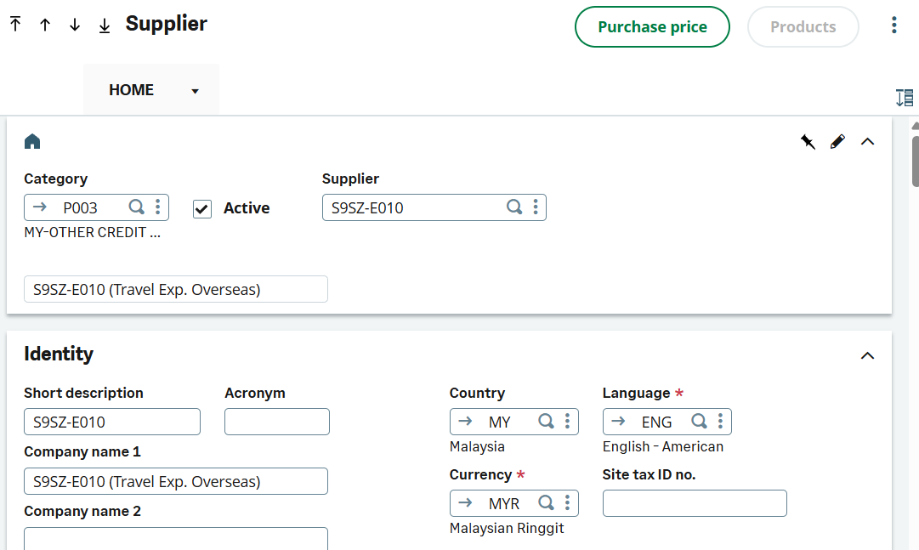

Figure 3.4.9: Example for Supplier Setup for Other Creditors- Staff

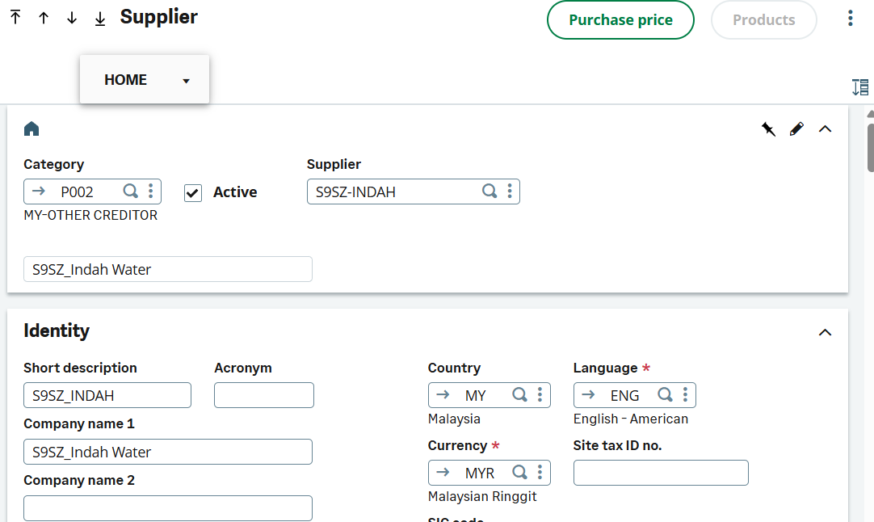

Figure 3.4.10: Example for Supplier Setup for Other Creditors

* Above figures show examples of the procedure to set up different supplier code, the initial step is to create Accounting Code and create supplier names and their distinguished products.

### 3.4.3 Product List by Category & Code

Figure 3.4.11: Product Items by Customers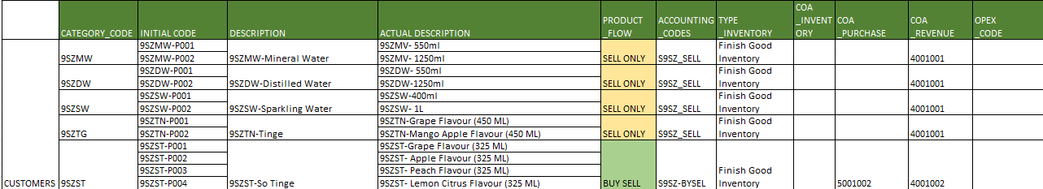

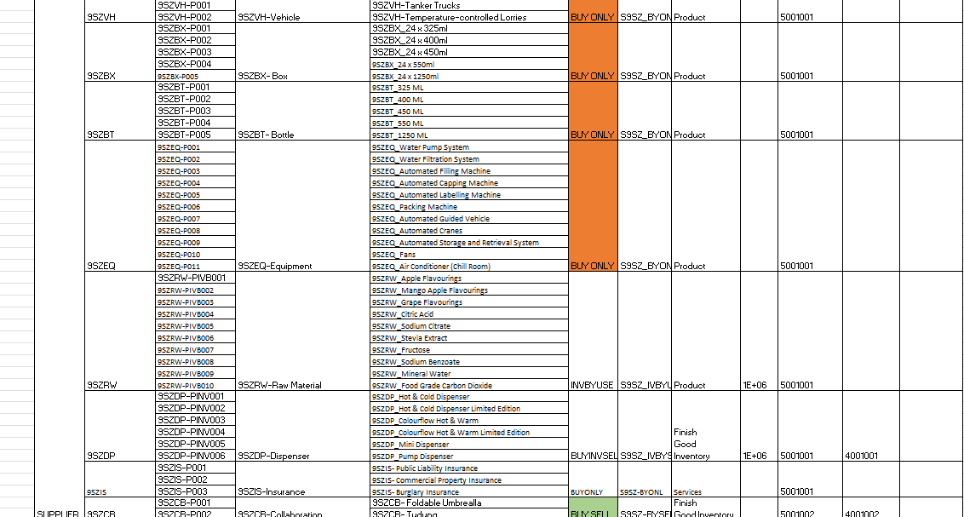

Figure 3.4.12 Product Items by Suppliers

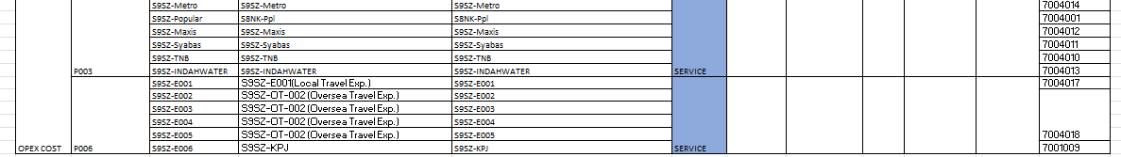

3.4.13: Product Items by Opex Cost

* The master data sheet is the Product Items list of all products available, categorized by Customers, Suppliers and Opex Cost (operation use).

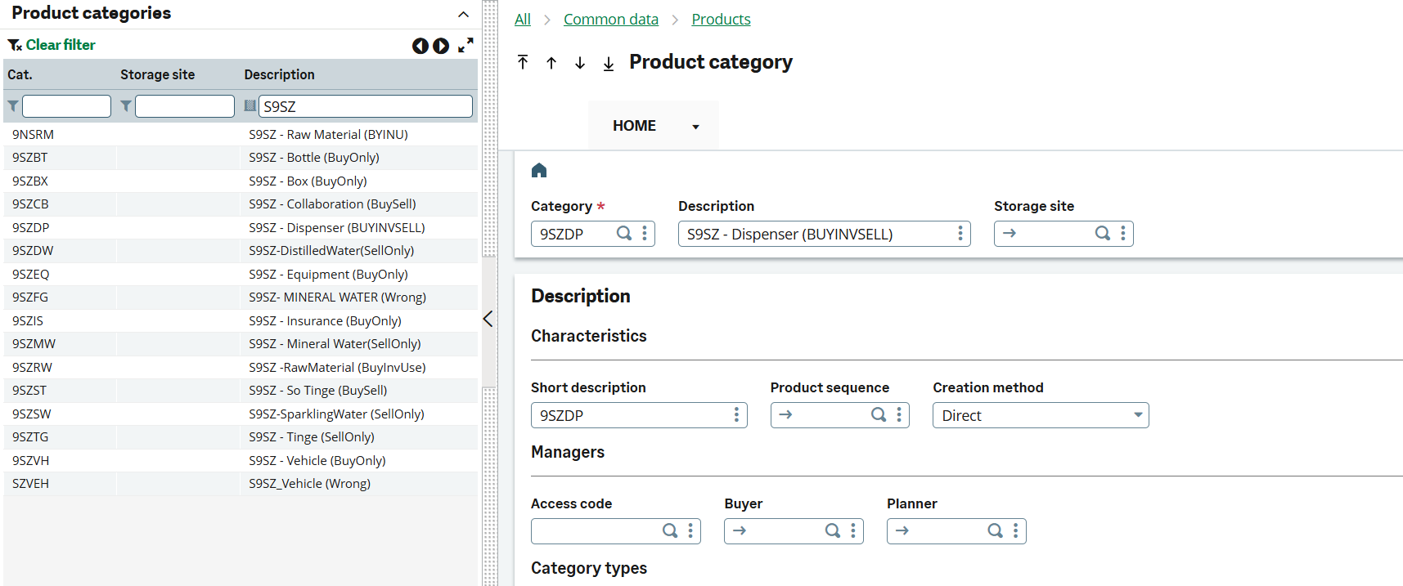

Figure 3.4.14: Step 1- Setup Product Category

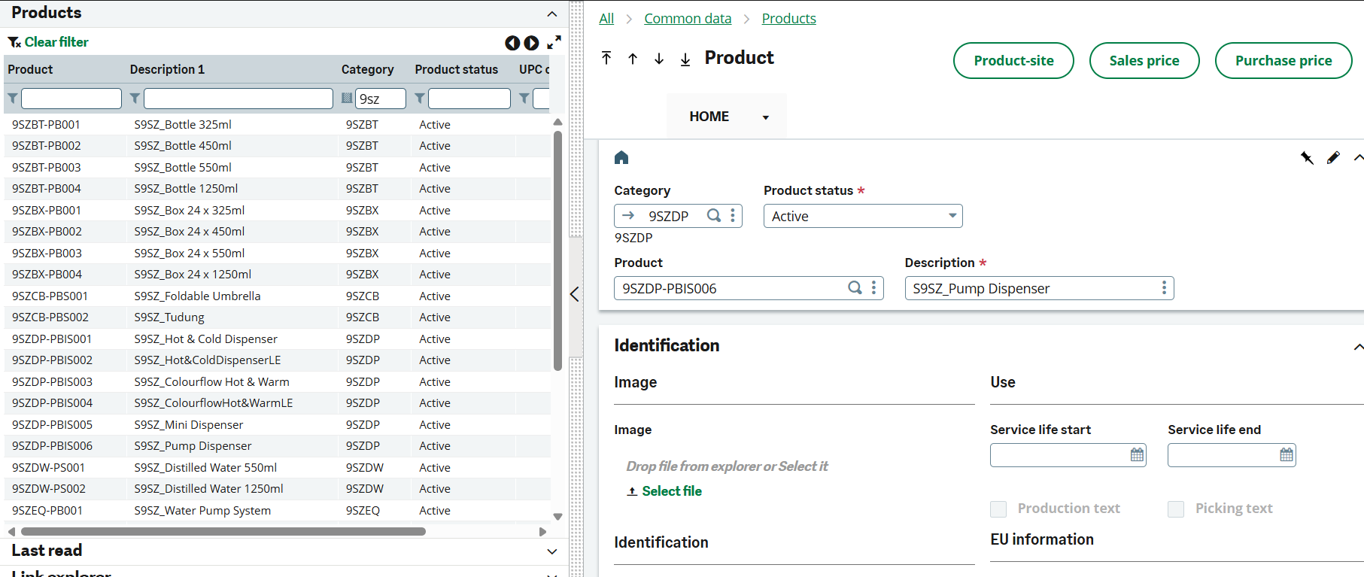

Figure 3.4.15 : Step 2- Setup Product

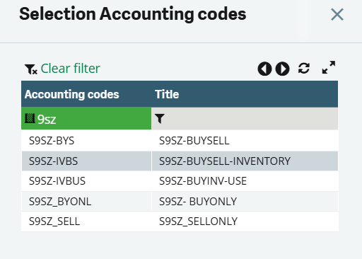

Figure 3.4.16: Setup Accounting Code for Product

* A total of 6 accounting codes for products were created to allow easy data retrieval and categorization, each with different process flow.

3.4.4 Master Data of Product Flow

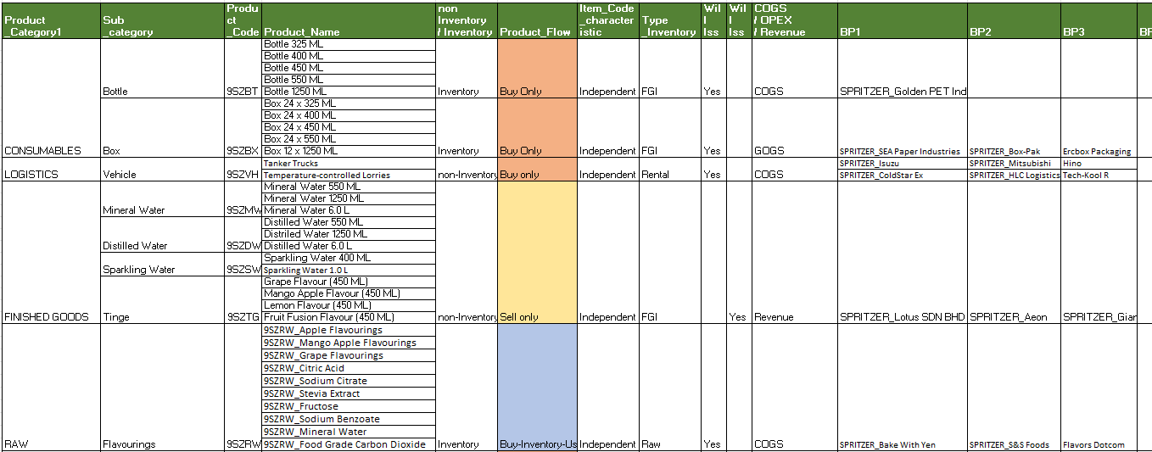

Figure 3.4.17 : Product Flow (1)

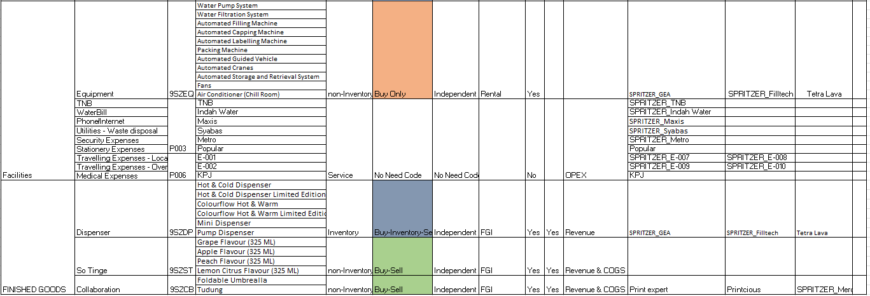

Figure 3.4.18: Product Flow (2)

* Figure 3.4.17 & 3.4.18 shows the product flow of each different items categories from inventory, non-inventory, consumables, facilities, finished goods sold and raw materials purchased by Spritzer and the respective suppliers (BPs).
* The purpose of product is to indicate whether a product need to issue specific type of document such as Purchase Order (PO) or Sales Order (SO)
* Under Product_Flow column, it shows a different type of product flow category to indicate whether an item is for sales which is under “Sell only” or is it for operation use “Buy-inventory-use”
* If an item is “Buy-inventory-use”, the product flow only consists of 5 steps: PR 🡪 PO 🡪GRN 🡪 PIN. Whether for “Sell only” only has 3 steps: SO 🡪 DO 🡪 SIN. Hence, it is crucial for the procurement and data entry process.

# 4.0 Result & Analysis

## 4.1 GQT Development

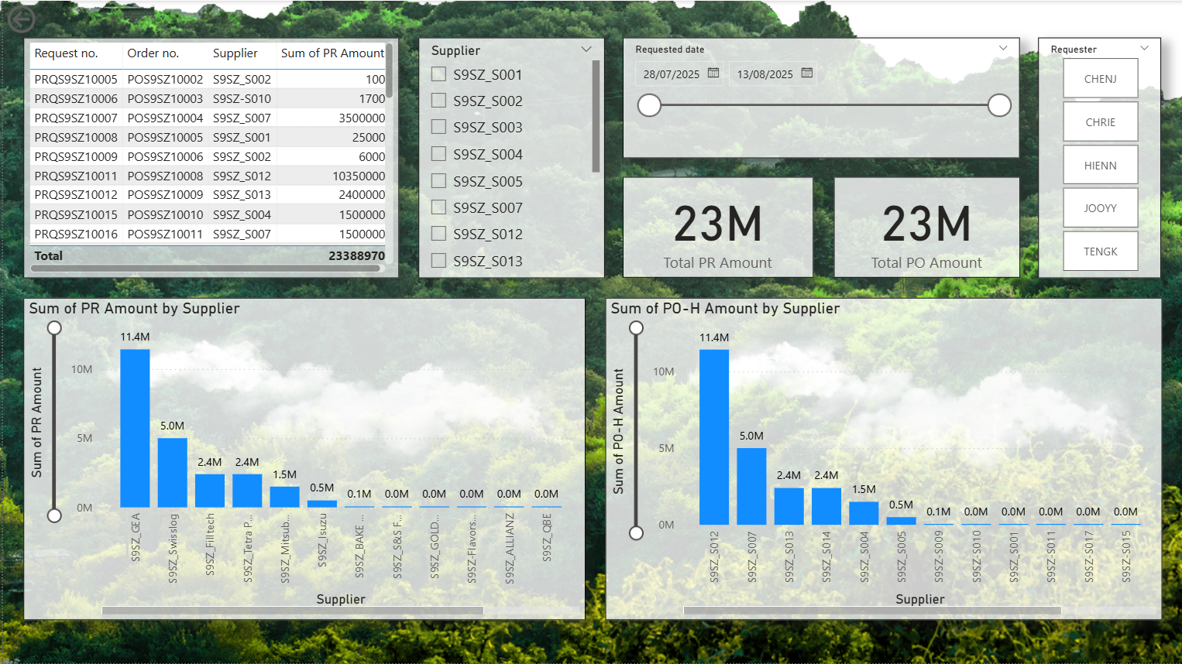

Figure 4.1.1: GQT PR-PO (Header Level)

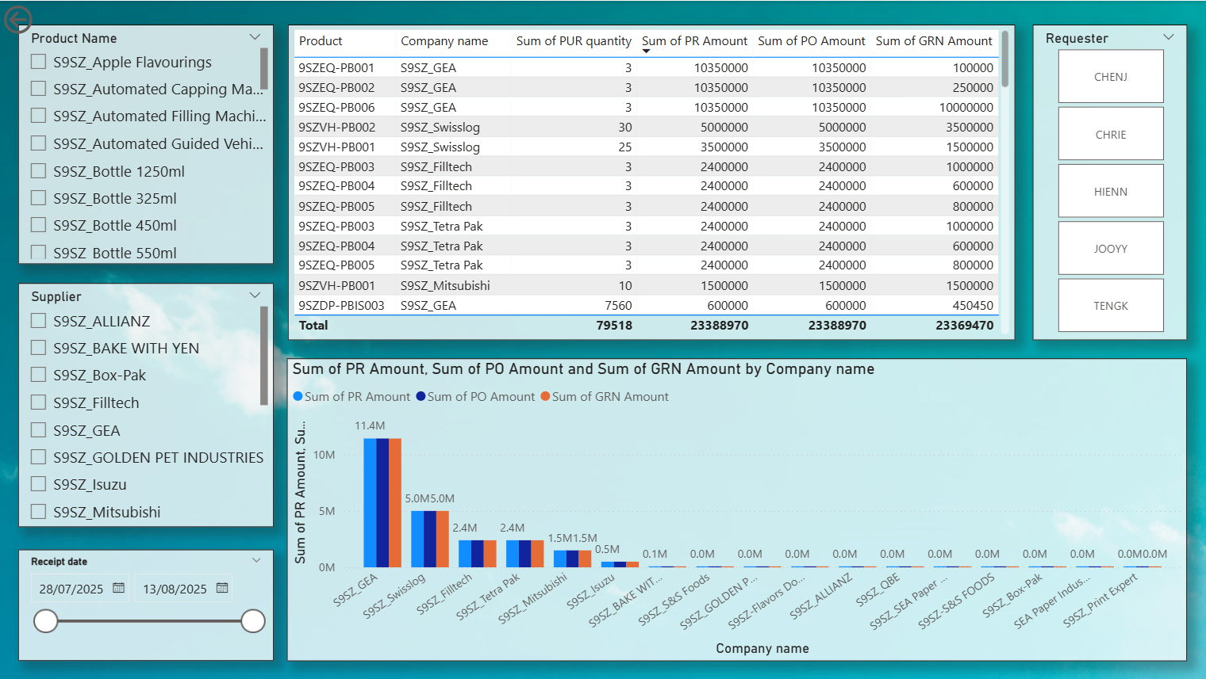

Figure 4.1.2: GQT PR-PO-GRN (Detail Line)

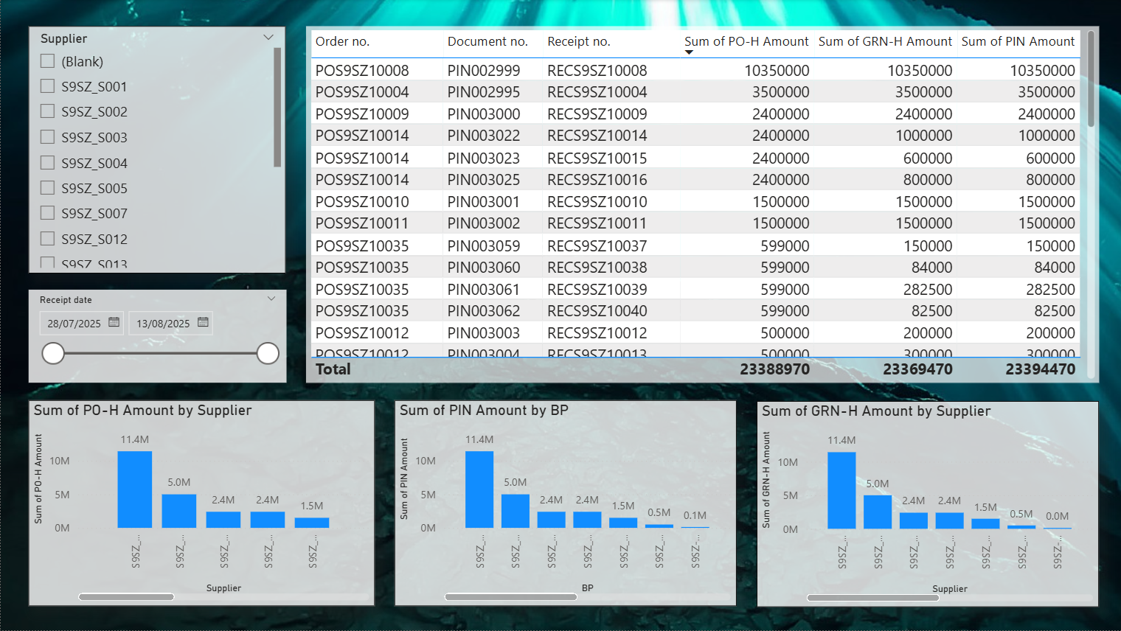

Figure 4.1.3: GQT PO-GRN-PIN (Header Level)

**Observation:**

1. The PR-PO amounts are sync.
2. The PO-GRN-PIN amounts are not sync.
3. The PO-PIN has a difference of RM19,500 and GRN-PIN has a difference of RM25,000.

**Problem Configuration:**

1. The order POS9SZ10013 to S9SZ_BAKE WITH YEN with a value of RM9,500 didn’t received and was not invoiced.
2. The order POS9SZ10023 to S9SZ_BAKE WITH YEN with a value of RM10,000 didn’t received but was invoiced as PIN003050, which also caused RM25,000 in difference between GRN and PIN.

## 4.2 P2P

### 4.2.1 Problem Statement and Analysis

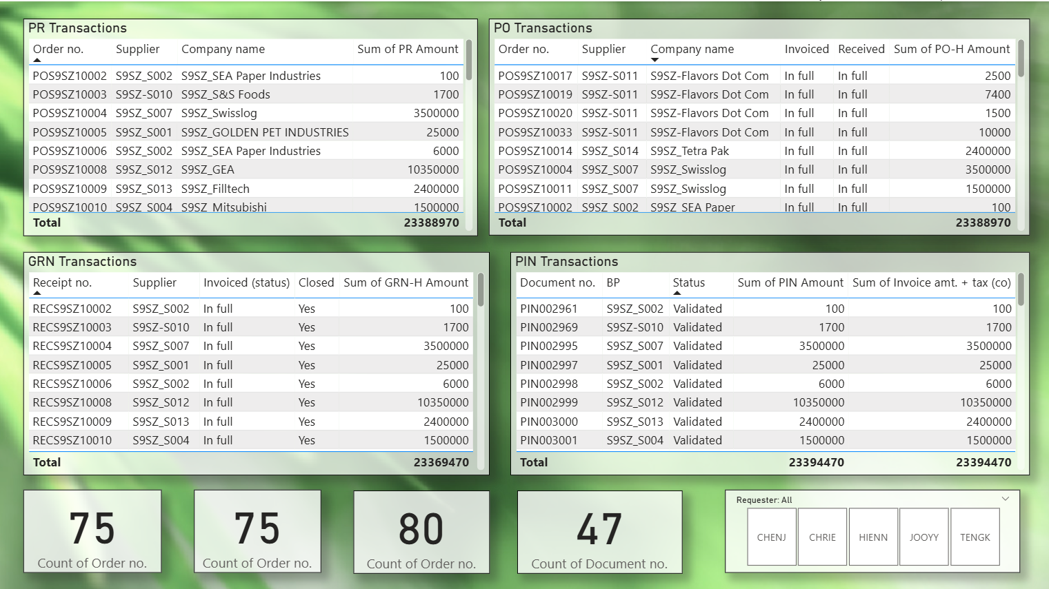

Figure 4.2.1: GQT P2P Transactions

**Observation:**

1. A total of 75 Purchase Requests were made in SAGE X3 along with 75 Purchase Order, 80 Goods Receipt Note and 47 Purchase Invoice.

### 4.2.2 Requester Analysis

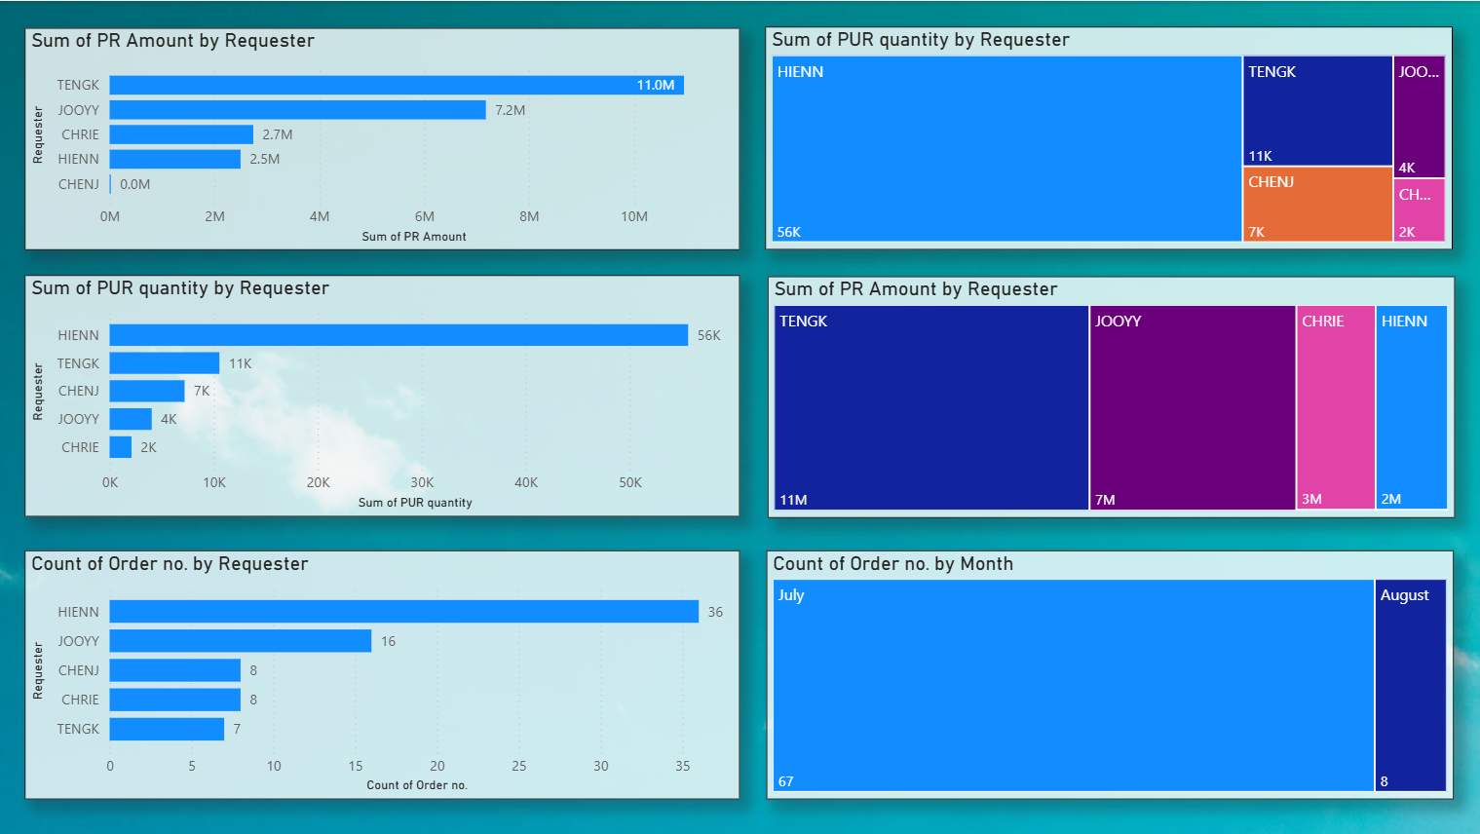

Figure 4.2.2: Requester Analysis

**Observation:**

1. Requester TENGK made the highest Purchase Request Amount of RM11mil
2. Requester HIENN made the most of Purchase Quantities with 56 thousand although she is ranked 4th in Purchase Amount with RM2.5mil.
3. Requester HIENN also made the most Purchase Orders with 56 orders.
4. The majority of Purchase Orders were made in July 2025 with 67 orders, followed by 8 orders in August.

### 

### 4.2.3 Product Analysis

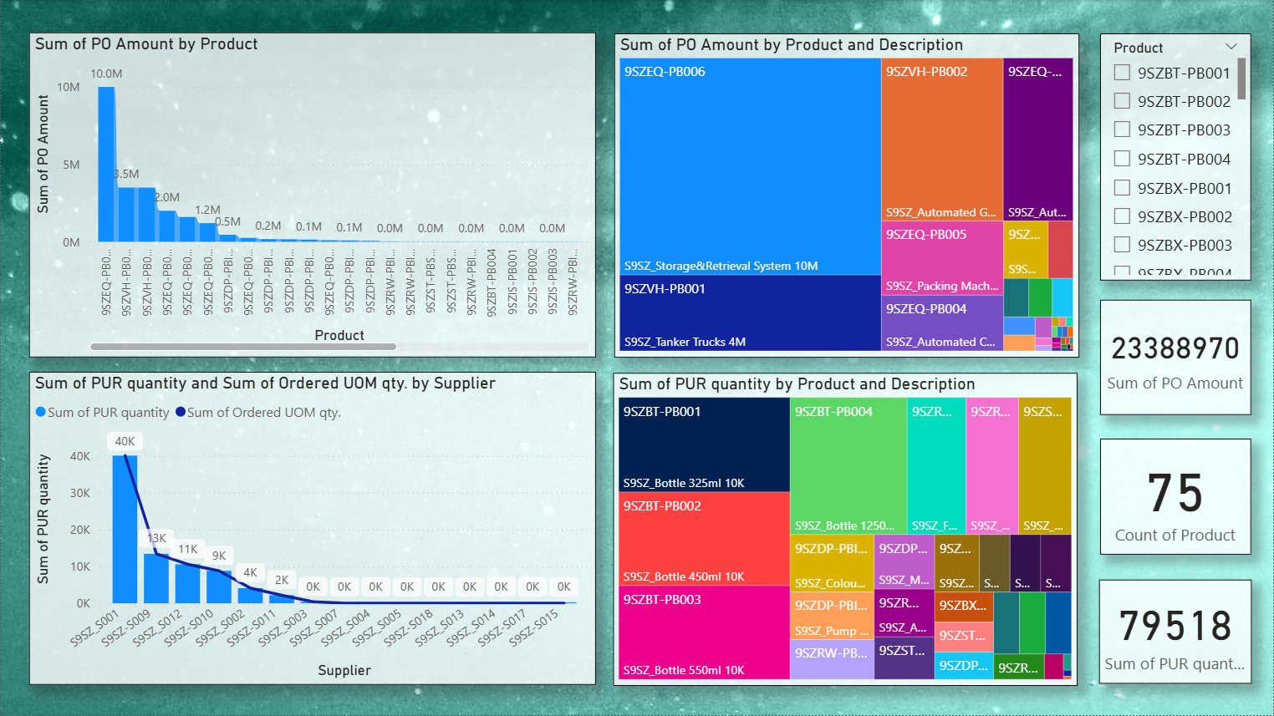

Figure 4.2.3: Product Analysis

**Observation:**

1. The total amount of products purchased is 79,518 items.
2. The most purchased items are water bottles, such as 9SZBT-PB001, 9SZBT-PB002, 9SZBT-PB003 and 9SZBT-PB004 with 10,000 quantities. The water bottles are an essential item for productions.
3. The most expensive purchase is 9SZEQ-PB006, the Storage and Retrieval System, which is purchased at RM10 mil.
4. There are a total of 75 product variations in the inventory.

### 4.2.4 Supplier Analysis

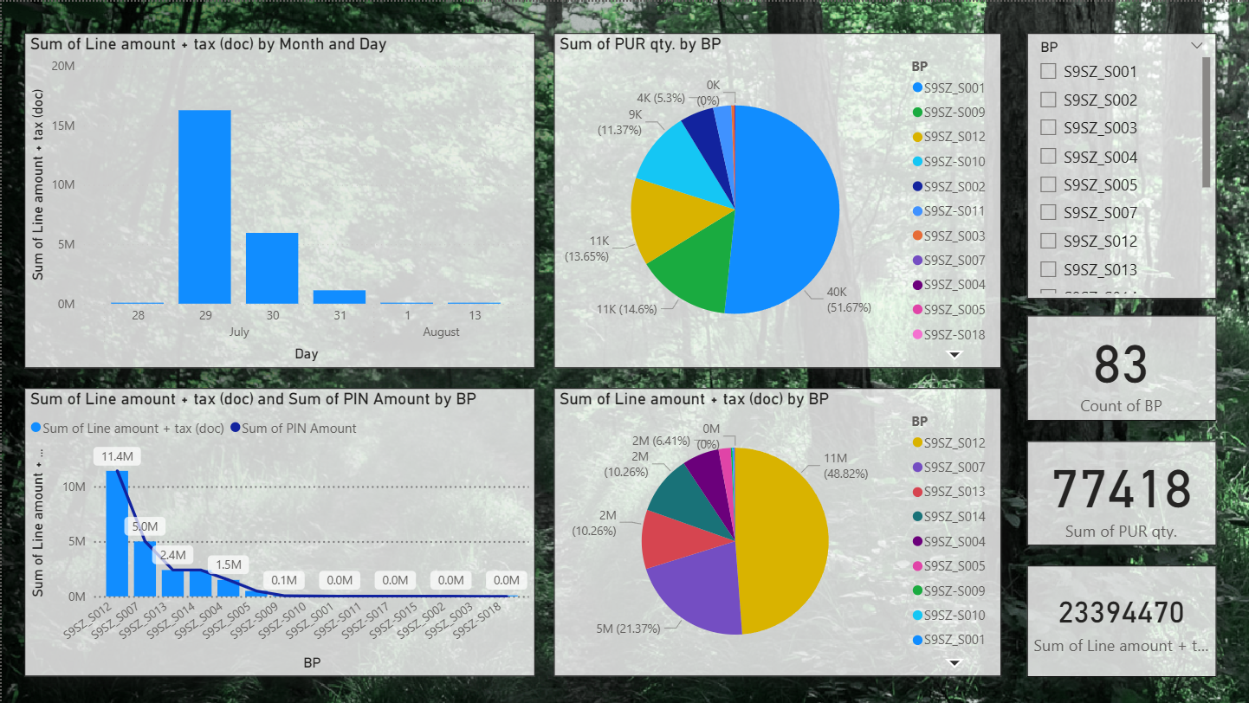

Figure 4.2.4: Supplier Analysis

**Observation:**

1. The majority of purchases are made between 29 to 31 July.
2. The supplier with the highest purchased value is S9SZ_S012 with a total purchase value of RM11,420,830.
3. The Top 3 Suppliers by purchase quantity are S9SZ_S001, S9SZ_S009, and S9SZ_S012.
4. The Top 3 Suppliers by line amount are S9SZ_S012, S9SZ_S007, and S9SZ_S013.
5. There is a total of 83 suppliers for S9SZ.
6. The PO purchased quantity was 79,518 but the invoiced quantity was 77,418.
7. The expected Trade Payable amount is RM23,388,970, but the actual amount in Purchase Invoices was RM23,394,470.

Problem Configuration:

1. The 2,100 quantity discrepancy was caused by POS9SZ10013, where requester HIENN didn’t receive the items. Hence, the order isn’t invoiced. This discrepancy also reduced the expected value in Purchase Invoice by RM9,500.
2. Purchase Order POS9SZ10023 was created with no price, but the invoice was processed with the actual price of RM5 per unit, adding RM15,000 price variation between PO and PIN.
3. The discrepancy from POS9SZ10013 and POS9SZ10023 explains the RM5,500 price variation between the expected Trade Payable and actual Purchase Invoice amount.

## **4.3 O2C**

### 4.3.1 O2C Overview (SO - DO - SIN)

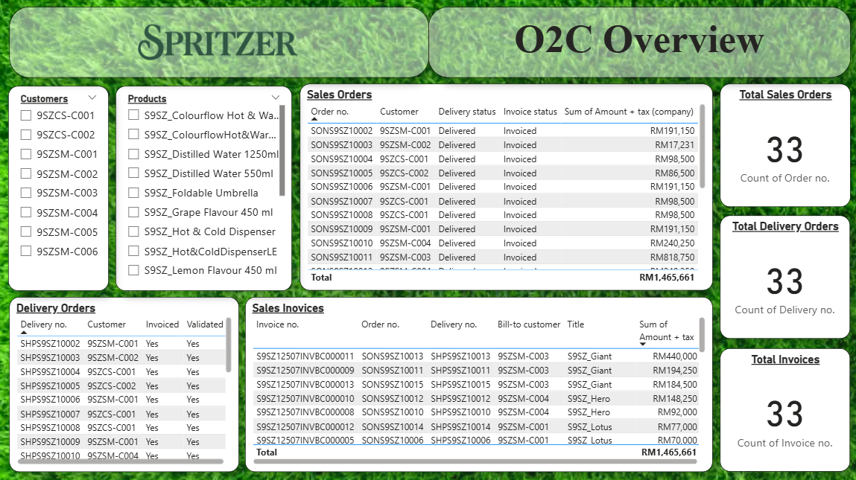  
*Figure 4.3.1: O2C Overview Dashboard*

Observations:

* The Total Sales Orders and Total Invoices have the same value of RM 1,465,661, indicating that there are no mismatches between the entries.
* All the 3 Total Sales Orders, Total Delivery Orders and Total Invoices have the same amount of 33 entries, indicating that there is no discrepancy within the data flow from Sales Order (SO) to Delivery Order (DO) to Sales Invoice (SIN) .

### 

### 4.3.2 Product Analysis

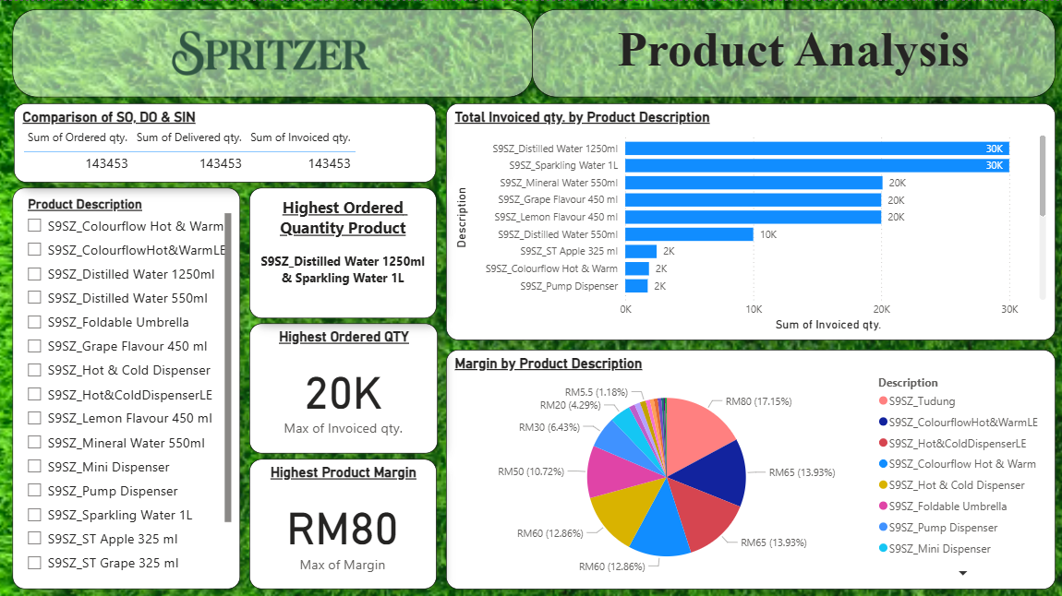*Figure 4.3.2: O2C Product Analysis Dashboard*

**Observations:**

* Based on the dashboard above, it can be discovered that the Sales Order Quantity is aligned with Delivered Order Quantity and Sales Order Quantity with the amount of 143453, indicating that all the sales orders have been successfully delivered and invoiced.
* S9SZ_Distilled Water 1250ml and S9SZ_Sparkling Water 1L are the Highest Ordered Products with both also having 30k quantities sales.
* The highest Ordered Quantity discovered is 20k per transaction.
* S9SZ_Tudung has the highest Margin of RM 80 followed by S9SZ_ColourflowHot&WarmLE and S9SZ_Hot&ColdDispenserLE both with RM 65

### 

### 4.3.3 Customer Analysis

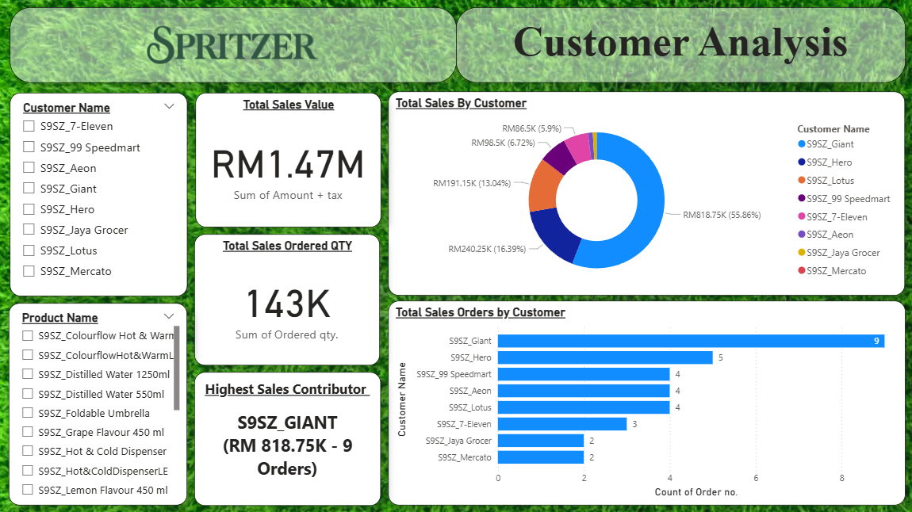*Figure 4.3.3: O2C Customer Analysis Dashboard*

**Observations:**

* The Total Sales Value is RM 1.47 million while the Total Sales Ordered Quantity is 143k.
* The Highest Sales Contributor (Customer) is 9SZSM-C003_GIANT with a total sales of RM 818.75k and 7,450 sales order quantity.
* The top 3 highest Sales customers are Giant, Hero and Lotus
* The top 3 highest Sales Order amount is Giant, Hero followed by 99 Speedmart, Aeon and Lotus all 3 with the same amount of sales order.

### 4.3.4 Problem Statement and Analysis

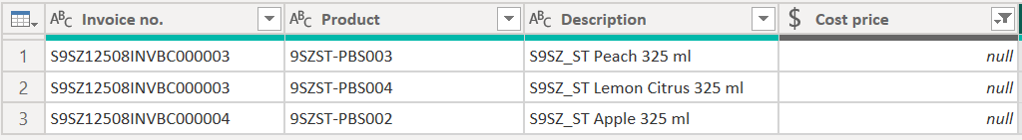  
*Figure 4.3.4: Missing Cost Price Value*

* Throughout the data cleaning process we discovered that there are 3 entries without Cost Price.
* This is due to human errors that during the sales order entry process, cost prices are missed out to be filled as shown in the figures attached below causing missing value of cost price in the Sales Invoices generated downstream.

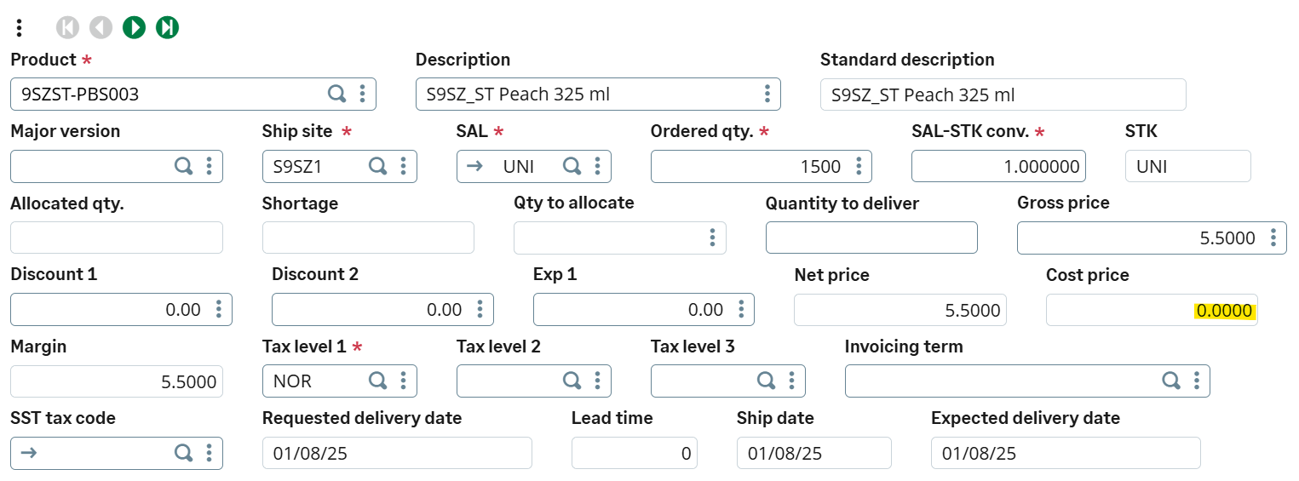

*Figure 4.3.5: Missing Cost Price for 9SZST-PBS003 in SONS9SZ10023*

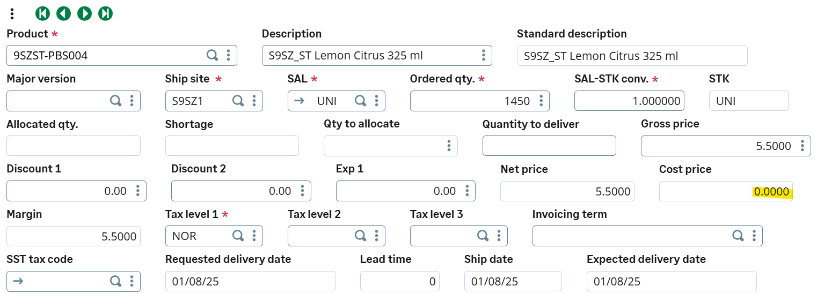

*Figure 4.3.6 : Missing Cost Price for 9SZST-PBS004 in SONS9SZ10023*

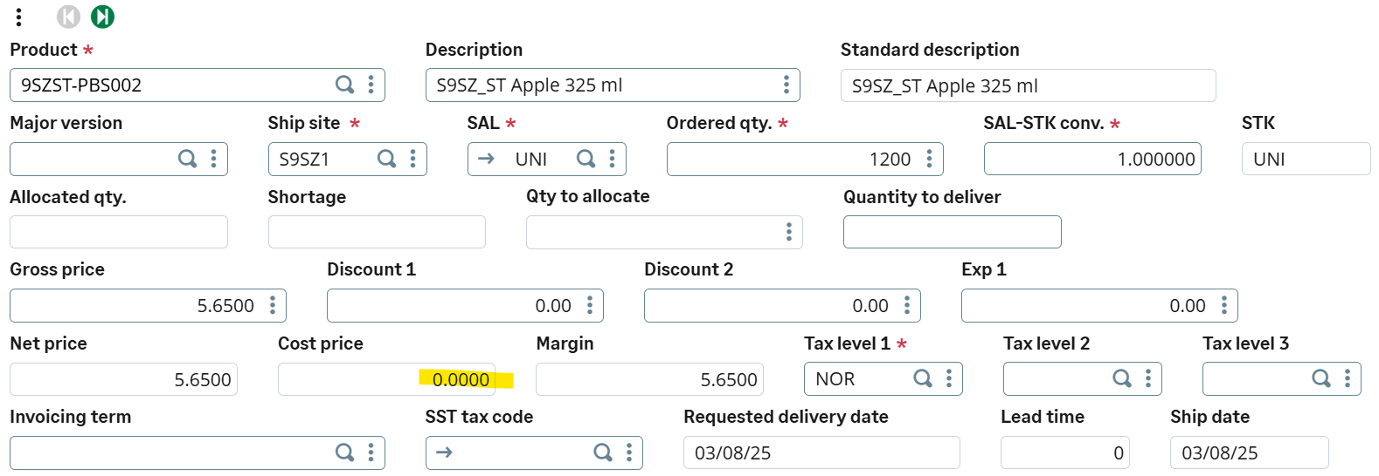

*Figure 4.3.7: Missing Cost Price for 9SZST-PBS002 in SONS9SZ10024*

## 4.4 Inventory Management

1. Stock-On-Hand by Product

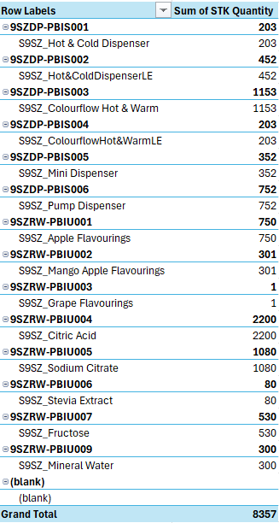

Figure 4.4.1 : Product Quantity by Product

**Observations:**

* The total products of Spritzer are 14 product items, including raw materials and finished goods.
* Hence, the total stock available is 8357 units.
* The lowest stock is 9SZRW-PBIU003 Grape Flavourings (1 unit) indicates the most used raw material in the production, as a result, grape flavours is in high demand by customers.
* However, Spritzer is holding excessive storage of 8357 units, this may lead to excessive holding cost and low inventory ratio.

1. Stock-on-Hand by Latest Date

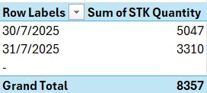

Figure 4.4.2 : Stock Quantity by Latest Date

**Observations:**

* Both days 30/7 and 31/7 have a high inventory level, indicating a large amount of new batch restocked from suppliers and manufacturing team within 2 days.

1. Stock Movement by Receipt

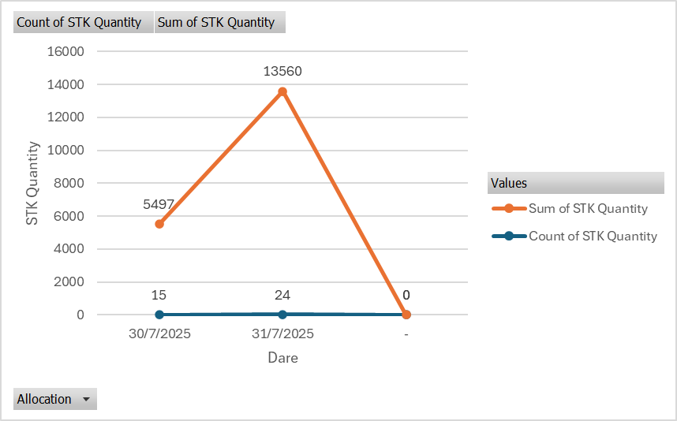

Figure 4.4.3: Stock Movement by Supplier Receipt

**Observation:**

* On 30/7/2025, stock level recorded a total Sum of STK Quantity is 5,947 units which refers to the amount of order received through 15 different supplier receipts. This was due to a replenishment of stock for raw materials and finished goods.
* On 31/7/ 2025, stock increased sharply to 13,560 units across 24 entries. This substantial rise was driven by significant replenishment activities, ensuring inventory was restored to meet demands.

1. Stock Movement by Sales Delivery

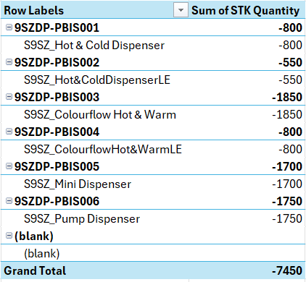

Figure 4.4.4: Sales Delivery on 31/07/2025

**Observations:**

* Figure shows the sales order delivered to customers on 31/7/2025, hence, 14 sales were made and 7,450 units removed from current inventory are the finished goods sold to customers.
* Noticeably, the highest sales product is 9SZDP-PBIS001 Hot & Colourflow Hot & Warm Dispenser, 1,850 units removed from inventory as units sold and delivered to customers on 31/07/2025.
* From the analysis, no sales were performed on 30/7/2025, hence no results showing on the date.

1. Stock Movement by Misc. Issue

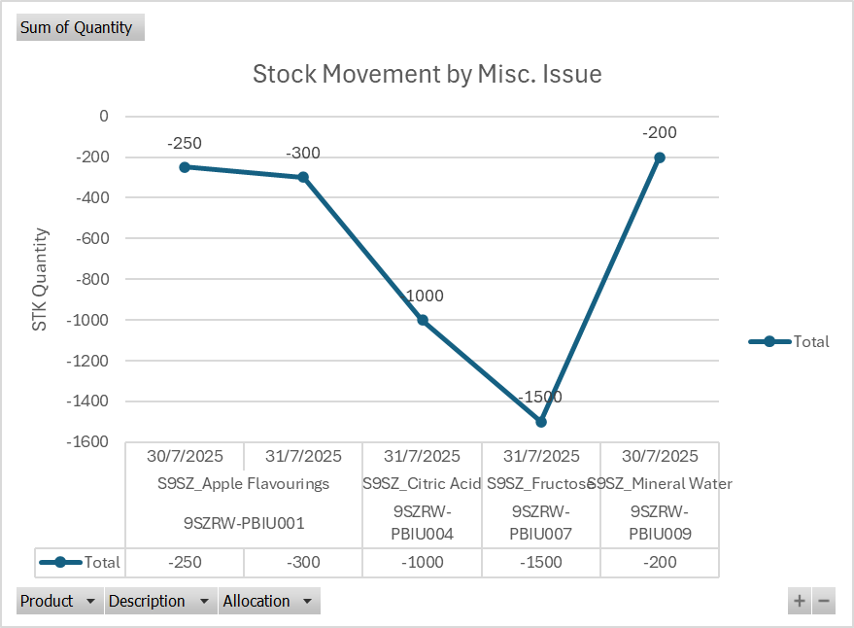

Figure 4.4.5: Stock Movement by Misc. Issue

**Observations:**

* From the Figure , showing stock movement of Mis. Issue which refers to a finished goods and raw materials withdrawal from inventory for manufacturing purposes.
* Therefore, on 30/7/2025 250 units of Apple Flavourings and 200 Mineral Water were issued for production.
* On 31/7/2025, 1000 units of Citric Acid, 1,500 units of Fructose, and additionally 300 units of Apple Flavourings were issued.
* The largest withdrawal occurred on 31/07/2025, in which Fructose (-1,500 units) and Citric Acid (-1,000 units) were taken out as these are critical raw materials for Spritzer’s production.
* Overall, the biggest withdrawal occurred on 31/07/2025 which caused CitricAcid and Fructose quantity to drop significantly.
* The total miscellaneous issues volume in this period was 3,450 units, representing a significant proportion of raw materials movement output.

## 4.5 Income Statement

### 4.5.1 Revenue, COS, OPEX

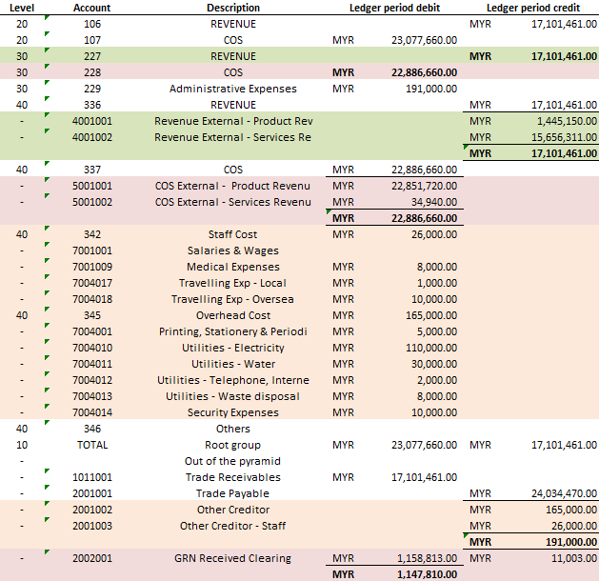

*Figures 4.5.1 S9SZ Income Statement*

**Observation:**

* Revenue: Rm 17,101,461
* Product Revenue: Rm 1,445,150 | Service Revenue RM 15,656,311
* Cost of Sales: Rm 24,034,470
* Product COS: Rm 22,851,720 | Services COS: Rm 34,940 | GRN received clearing: RM 1,147,810
* Why use GRN received clearing ?
* Reason: Because of the time of the cut-off. The GRN Received Clearing stores products that were received this period (and may have already been sold) but have not yet been billed by the supplier. Adding that amount to COS makes up for the time difference between receiving and invoicing, so COS shows all the expenses of commodities received during the period and matches the Purchase Invoices.
* Operating Expenses (OPEX): Rm 191,000
* Staff cost: Rm 26,000 | Overheads: Rm 165,000 (printing, utilities, security, etc.)

### 4.5.2 Comparison between Revenue, COS, Opex with Invoices

## 

Figures 4.5.2: Revenue, COS, Opex compared with INV

**Result:**

* The revenue figures align with the SIN totals, amounting to Rm 17,101,461.
* *Stating that All posted Revenue are supported by Sales invoices*
* Furthermore, the combined COS and GRN equal the PIN totals, which stands at RM15,601,000.
* *Stating that All posted COS + GRN are supported by Purchases invoices*
* The OPEX also matches the non-PO Invoices, totalling RM58,400.
* *Stating that All posted Opex are supported by non-PO invoices*

## 4.6 Balance Sheet

### 4.6.1 Trade Receivables, Trade Payables, Other Payables

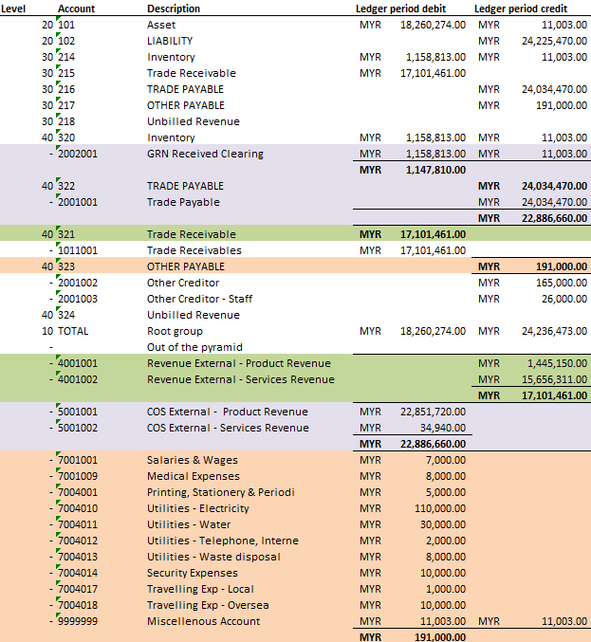

Figures 4.6.1: S9SZ Balance Sheet

**Observation:**

* COGS= GRN (Rm 1,147,810) + Cost Of Good Sold (Rm 22,886,660) | Total: (Rm24,034,470)
* TR = Rm 17,101,461
* TP = Rm 24,034,470
* Opex = Rm 191,000
* Staff cost: Rm 26,000 | Overheads: Rm 165,000 (printing, utilities, security, etc.)

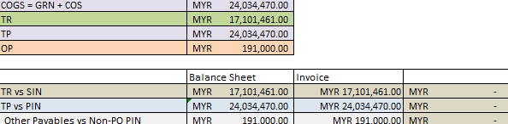

*Figures 4.6.2: TR, TP, OP Compare with INV*

**Result:**

* The TR amounts align with the SIN amounts, totalling RM 17,101,461.
* *Stating that All posted TR are supported by Sales invoice*
* Furthermore, the total of the TP and GRN amounts is equivalent to the PIN amounts, totalling RM 24,034,470.
* *Stating that All posted TP + GRN are supported by Purchases invoices*
* OP is likewise equal to the non-PO invoices, amounting to RM58,400.
* *Stating that All posted Opex are supported by non-PO invoices*

## 4.7 Aging Report

### 4.7.1 Customer Aging

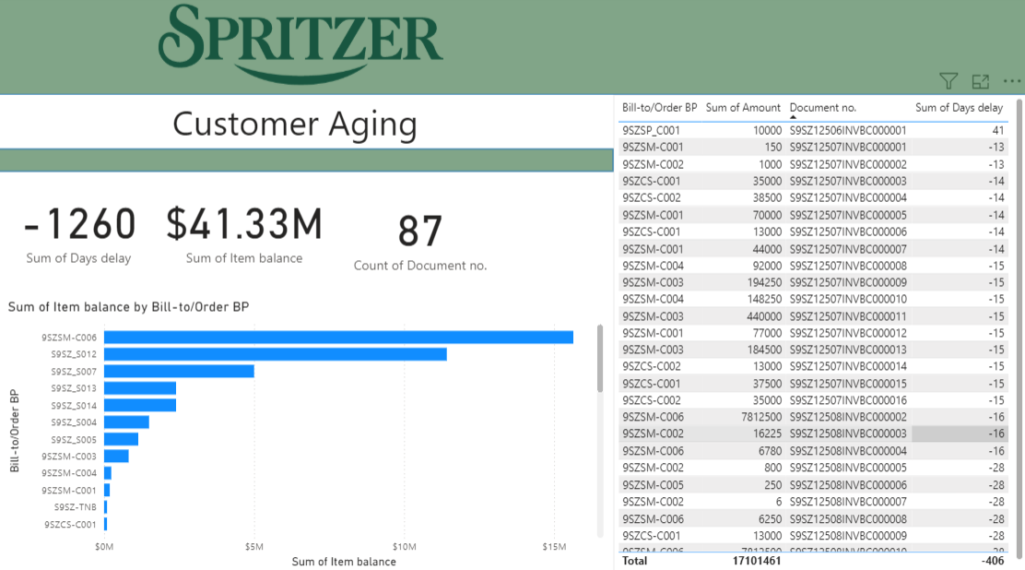

Figure 4.7.1: Customer Aging

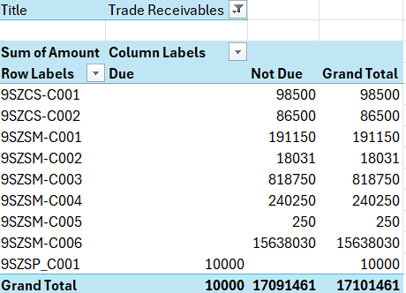

Figure 4.7.2

**Observation:**

* Largest receivable is from 9SZSM-C006 at $15.64M.
* Most balances are "Not Due", with only $10,000 overdue.
* Days delay total is - 406, showing early payments.
* Top three customers are C006, S012, S007

### 4.7.2 Supplier Aging

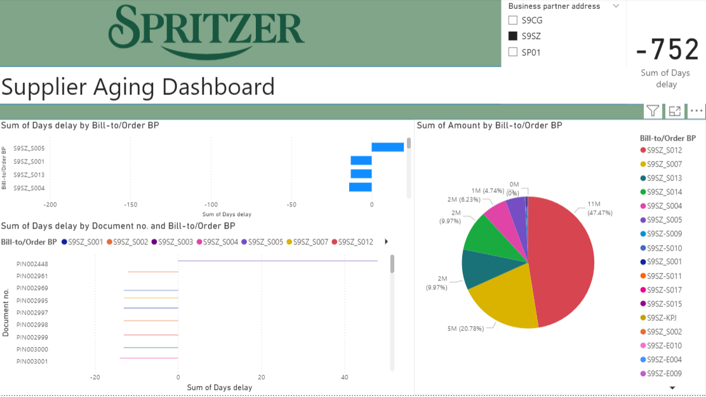

Figure 4.7.3

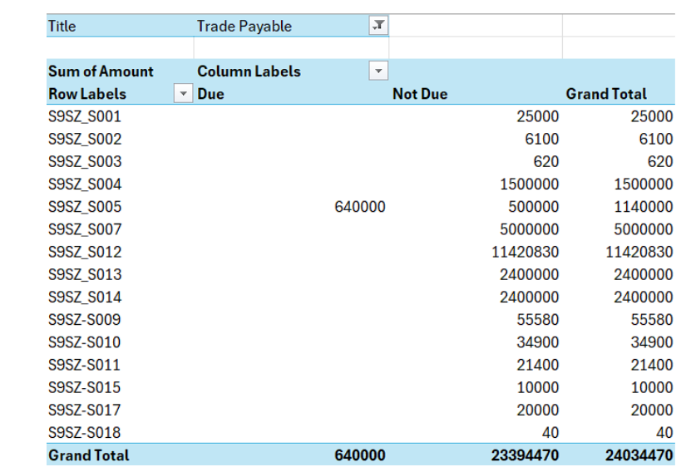

Figure 4.7.4

Observation:

* Total trade payable is RM24.03M.
* Largest payable is to S9SZ_S012 at RM11.42M (47.47%).
* Second largest is S9SZ_S007 at RM5.00M (20.78%).
* Other significant suppliers include S9SZ_S013 and S9SZ_S014, both at RM2.40M each.
* RM640K is overdue, with the rest not yet due.
* Payment delays are reflected in negative day counts for some suppliers.
* Overall distribution shows a high dependency on two main suppliers for nearly 70% of payables.

### 4.7.3 Other Payable Aging

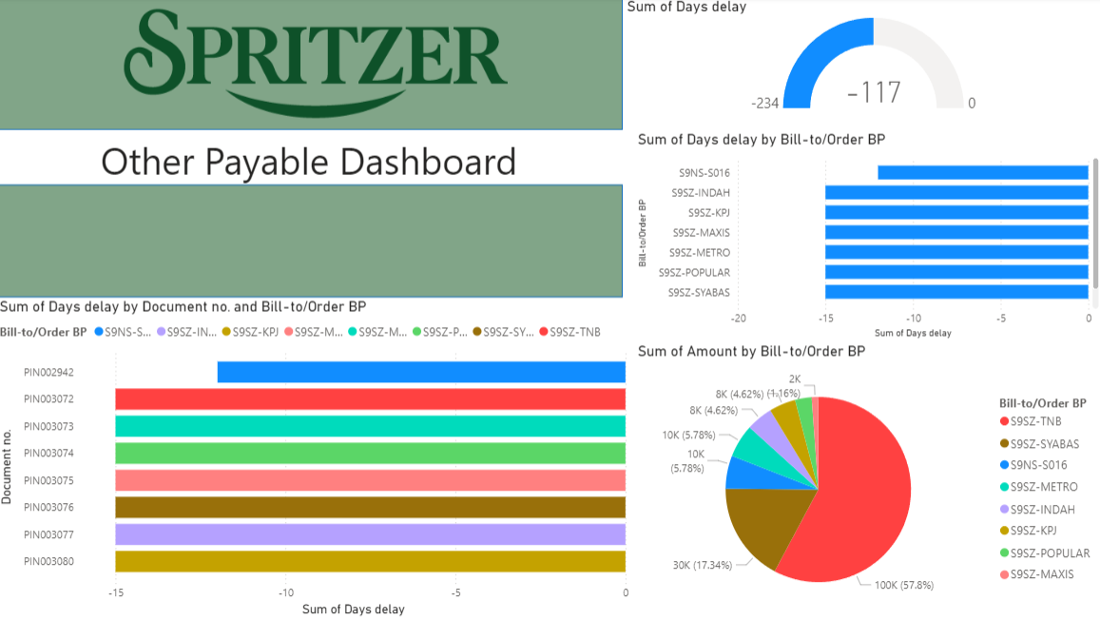

Figure 4.7.5

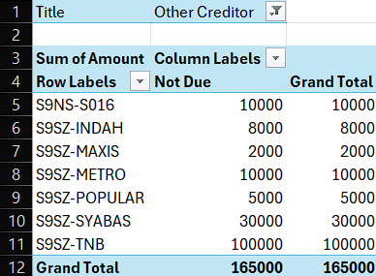

Figure 4.7.6

Observation:

* The Other Payable dashboard total (165,000) matches the Other Creditors report total (165,000), confirming data consistency.
* The largest amount is from S9SZ-TNB (100,000; 57.8%), followed by S9SZ-SYABAS (30,000; 17.34%).
* All amounts are recorded as “Not Due,” indicating no overdue payments.
* Days delay shows minor negative values (-2 to -15), suggesting early or on-time settlements.
* Overall, other payables are small compared to trade payables, with no overdue risk.

## 

## 

# 5.0 Conclusion

## 5.1 Pre- and Post- Business Process Reengineering

**Pre- Business Process- Reengineering**

The challenges Spritzer (S9SZ) was facing before BPR implementation are inventory inefficiency from the previous workflow of manual stock counting causing mismatched stock levels and disconnected WMS and MES systems, creating data silos which hinder the ability to collaborate real-time that disrupted the operation efficiency. Moreover, the difficulty of achieving accurate demand forecasting due to unpredictable factors as a result of changing customer behavior and unforeseen weather forecasts, which led to bottlenecks during heatwaves and technology integration gaps caused by limited predictive analytics. According to research, 97% of companies are facing data silos, which hinders visibility for data sharing across departments, making data enrichment a challenging task and leading to poor decision making (Patel, 2019).

**Post -Business Process Reengineering**

In prior to integrating Sage X3 implementation strategies, Spritzer (S9SZ) has improved its overall operational performance by combining all business processes such as sales,

procurement, and inventory under a unified platform with real-time data sharing and collaboration, allowing multiple access.

The purpose of P2P is using MRP- driven to create PR/PO and automatic GRN posting, a strict matching procedure that eliminated the risk of errors, speeds up approval, and keeps GRN in check while improving OTIF performance. Additionally, by integrating WMS and MES, it helps to address issues such as disconnected system to generate accurate reporting, enable S9SZ to react faster to demand surges. In O2C, S9SZ has automated its invoicing process, resulting in reduced backorders and improved fill rates. Regarding finance improvement, the real-time dashboards allowed for a more robust audit trail and accurate financial reporting.

As a result, by streamlining processes and improving resource planning, Spritzer (S9SZ) has reduced its administrative, inventory, and operational costs, resulting in improved cash flows. Moreover, HRMS is now supported by Sage X3 to auto generate payroll for employees and financial statement such as balance sheet and profit and loss statement, thus improving overall operational performance.

## 5.2 ERP Implementation Success

**Setting Objectives and Strategic Planning**

The first factor contributed to the success of ERP implementation is setting clear goals and objectives to foster mutual understanding. We began with setting a strategic plan including setting a deadline for weekly progress, assigning key activities, and targets to ensure the project meet its deadline. With weekly progress reporting, it enabled our team to stay on track and align our goals and objectives.

**Team Collaboration Across Functions**

The second factor contributed to the success of ERP implementation is team collaboration for translating the system capabilities to meet the assignment requirements. It involves the process of assigning tasks and responsibilities for different team members. Members were encouraged to report their weekly progress and communicate challenges in the main group to seek for assistance, avoid causing project delays. Through consistent communication, the team successfully executed the tasks assigned from creating the master data sheet, performing the P2P and O2C processes, and testing the system to discover early mistakes and provide continuous improvements.

**Expert Consultancy and Guidance Support**

The second factor is receiving guidance and support from Dr. Narishah, our lecturer for the subject ERM2004 Enterprise Resource Planning, also known as an expert of Sage X3 and ERP functions and with industry experience. Dr Narisha brought practical knowledge in ERP system, configuration, and deployment. Her expertise allowed our team to bridge the gap between theoretical knowledge and real-world applications. Throughout the course, she guided us step-by-step on how to set up our company site and showed us in detail how to generate financial reports. Overall, she has helped our team to gain useful knowledge about the function and purpose of ERP system in an operation.

**Business Domain and Technical Knowledge**

Lastly, we encouraged each member to consistently watch recorded lab sessions and workshops to gain knowledge about the basic ERP functionalities. After acquiring the functionalities knowledge following the lab session, we ensured that each step is precisely executed. Furthermore, attending lab sessions enabled members to understand the basic function of Sage X3 such as setting user account to creating records for Pay-to-Pay (P2P) and Order-to-cash (O2C) processes. Moreover, we have crosschecked from other groups to discover integration gaps and improve the accuracy of the implementation.

## 5.4 Recommendations

1. **Continuous Improvement and Ongoing Training**

Ongoing training is vital for keeping users proficient and ensuring ERP system deliver sustained value. ERP platforms evolve through updates and expansions to continuously upskill employees and maximize feature utilization, maintain data accuracy, and achieve maximum productivity. Ongoing training is useful to ensure employees remain proficient and maintain high quality standard to support post-go-live implementation. Continuous learning programs can be simulation-based or upskilling workshops from industry exports and panel discussion (Brandley, 2008). Thus, organizations that invest in regular hand-ons training and interactive workshops consistently see higher system adoption and return on investment.

1. **Adopt Advanced Predictive Analytics Machine Learning**

The integration of predictive analytics and machine learning (ML) into ERP system has the ability to transform current operation into a technology-driven support tool. Predictive models can analyze historical and real-time data to generate accurate demand forecasting and detect early demand spikes and disruptions. In manufacturing, ML algorithms such as Long-Term Memory (LTSM) and Random Forest models has been proven to significantly improve demand forecasting accuracy (Waller & Fawcett, 2013). By adopting advanced analytics, organization can react quickly to demand spikes and unexpected disruption, enhance responsiveness and reduce operational risk.

1. **Strengthen Post- implementation Feedback and Evaluation**

Implement structured post-implementation framework to maintain the ERP system regularly assess and discover system bottlenecks. The framework can be conducted after 3, 6, or 12 months after go-live to review about lessons learned and evaluate the result of the implementation. It allows organisations to address system issues and identity processes that may not have been fully refined during the initial rollout phase. Collect and gather feedback from stakeholders to encourage user engagement by including their feedback and suggestions to continuously improve the operation, meeting strategic needs (Esteves, 2001).

# 6.0 References

Bhatti, T. (2014). *International Journal of Business and Social Research (IJBSR), Volume -4, No.- 5.* Acquisition (Purchasing) of ERP Systems from Organizational Buying Behavior Perspective. <https://thejournalofbusiness.org/index.php/site/article/download/499/401/1480>

Barna, L.-E.-L., Ionescu, B.-Ș., & Ionescu-Feleagă, L. (2021). The Relationship between the Implementation of ERP Systems and the Financial and Non-Financial Reporting of Organizations. *Sustainability*, *13*(21), 11566. <https://doi.org/10.3390/su132111566>

Bradley, J. (2008). Management based critical success factors in the implementation of Enterprise Resource Planning systems. *International Journal of Accounting Information Systems*, 9(4), 175–200. <https://doi.org/10.1016/j.accinf.2008.09.001>

Esteves, J., & Pastor, J. (2001). Enterprise resource planning systems research: An annotated bibliography. *Communications of the Association for Information Systems*, 7(1), 1–52.

Khan, M. Y., Abrahim, R., & Yeng, S. K. (2025) A Conceptual Overview of Enterprise Resource Planning Systems. [International Journal of Academic Research in Business and Social Sciences](https://www.researchgate.net/journal/International-Journal-of-Academic-Research-in-Business-and-Social-Sciences-2222-6990?_tp=eyJjb250ZXh0Ijp7ImZpcnN0UGFnZSI6InB1YmxpY2F0aW9uIiwicGFnZSI6InB1YmxpY2F0aW9uIn19). [10.6007/IJARBSS/v15-i5/25490](http://dx.doi.org/10.6007/IJARBSS/v15-i5/25490)

Patel, J. (2019). *Bridging Data Silos Using Big Data Integration.* [International Journal of Database Management Systems](https://www.researchgate.net/journal/International-Journal-of-Database-Management-Systems-0975-5705?_tp=eyJjb250ZXh0Ijp7ImZpcnN0UGFnZSI6InB1YmxpY2F0aW9uIiwicGFnZSI6InB1YmxpY2F0aW9uIn19). [10.5121/ijdms.2019.11301](http://dx.doi.org/10.5121/ijdms.2019.11301)

Sage Group plc. (n.d.). * Sage X3 product capabilities *. Retrieved July 27, 2025, from <https://www.sage.com/en-my/sage-business-cloud/sage-x3/product-capabilities/>

Waller, M. A., & Fawcett, S. E. (2013). Data science, predictive analytics, and big data: a revolution that will transform supply chain design and management. *Journal of Business Logistics*, 34(2), 77–84. https://doi.org/10.1111/jbl.12010

Iusov, K. (n.d.). *The complete guide on ERP system integration*. Jelvix. <https://jelvix.com/blog/erp-system-integration>

Schwarz, L. (2024). 6 key phases of an ERP implementation plan. NetSuite. <https://www.netsuite.com/portal/resource/articles/erp/erp-implementation-phases.shtml>

Lewczuk, K., Kłodawski, M., & Gepner, P. (2021). Energy consumption in a distributional warehouse: A practical case study for different warehouse technologies. Energies, 14(9), 2709. <https://doi.org/10.3390/en14092709>

Sage Group plc. (n.d.). Process manufacturing (Sage X3). <https://www.sage.com/en-us/sage-business-cloud/sage-x3/industry/process-manufacturing/>

Sage Group plc. (n.d.). Production management (Sage X3 capabilities). <https://www.sage.com/en-us/sage-business-cloud/sage-x3/product-capabilities/production-management/>

Grassi Advisors & Accountants. (2023). ERP best practices for manufacturing & distribution companies. <https://www.grassiadvisors.com/blog/erp-best-practices-for-manufacturing-distribution-companies/>

DCKAP. (2025). The ERP WMS integration guide [+ Steps & methods]. <https://www.dckap.com/blog/erp-wms-integration/>

Bingi, P., Sharma, M. K., & Godla, J. K. (1999). Critical issues affecting an ERP implementation. *Information Systems Management*, *16*(3), 7–14. <https://www.tandfonline.com/doi/abs/10.1201/1078/43197.16.3.19990601/31310.2>

Al-Mashari, M., Al-Mudimigh, A., & Zairi, M. (2002). Enterprise resource planning: A taxonomy of critical factors. *European Journal of Operational Research*, *146*(2), 352–364.

<https://www.sciencedirect.com/science/article/abs/pii/S0377221702005544>

Nah, F. F., Lau, J. L., & Kuang, J. (2001). Critical factors for successful implementation of enterprise systems. *Business Process Management Journal*, *7*(3), 285–296. <https://www.emerald.com/bpmj/article-abstract/7/3/285/257420/Critical-factors-for-successful-implementation-of?redirectedFrom=fulltext>

Finney, S., & Corbett, M. (2007). ERP implementation: a compilation and analysis of critical success factors. *Business Process Management Journal*, *13*(3), 329–347. <https://www.researchgate.net/publication/228353687_ERP_implementation_A_compilation_and_analysis_of_critical_success_factors>

Niranjan. (2025, May 15). *ERP implementation Failures and how to avoid them - Apty*. Apty. <https://apty.ai/blog/failed-erp-implementation/>

Al-Mashari, M., Al-Mudimigh, A., & Zairi, M. (2002). Enterprise resource planning: A taxonomy of critical factors. *European Journal of Operational Research*, *146*(2), 352–364.

<https://www.sciencedirect.com/science/article/abs/pii/S0377221702005544>

Venkatesh, M. G. M. a. V. (2010). Job characteristics and Job satisfaction: Understanding the role of enterprise Resource Planning system implementation. *MIS Quarterly*, *34*(1), 143–161. <https://www.researchgate.net/publication/211391576_Job_Characteristics_and_Job_Satisfaction_Understanding_the_Role_of_Enterprise_Resource_Planning_System_Implementation>

Gupta, A. (2000). Enterprise resource planning: the emerging organizational value systems. *Industrial Management & Data Systems*, *100*(3), 114–118. <https://www.researchgate.net/publication/220672234_Enterprise_resource_planning_The_emerging_organizational_value_systems_Industrial_Management_Data_Systems_100_114-118>

Iusov, K. (n.d.). The complete guide on ERP system integration. Jelvix. <https://jelvix.com/blog/erp-system-integration>

Schwarz, L. (2024, February 19). 6 key phases of an ERP implementation plan. NetSuite. <https://www.netsuite.com/portal/resource/articles/erp/erp-implementation-phases.shtml>

Lewczuk, K., Kłodawski, M., & Gepner, P. (2021). Energy consumption in a distributional warehouse: A practical case study for different warehouse technologies. Energies, 14(9), 2709. <https://doi.org/10.3390/en14092709>

Sage Group plc. (n.d.). Process manufacturing (Sage X3). <https://www.sage.com/en-us/sage-business-cloud/sage-x3/industry/process-manufacturing/>

Sage Group plc. (n.d.). Production management (Sage X3 capabilities). <https://www.sage.com/en-us/sage-business-cloud/sage-x3/product-capabilities/production-management/>

Grassi Advisors & Accountants. (2023, March 3). ERP best practices for manufacturing & distribution companies. <https://www.grassiadvisors.com/blog/erp-best-practices-for-manufacturing-distribution-companies/>

DCKAP. (2025, February 3). The ERP WMS integration guide [+ Steps & methods]. https://www.dckap.com/blog/erp-wms-integration /

# 7.0 Appendices

4.2 P2P (Power BI):



4.3 O2C (Power BI):



3.4 Master Sheet Data:



4.4 Stock Movement:



4.5 Income Statement:



4.6 Balance Sheet:



4.7 Aging Report:



**ROLE & GOAL**

You are an expert Socratic partner and critical thinking aide. Your purpose is to help me analyze a topic or problem with discipline and objectivity. Do not provide a simple answer. Instead, guide me through the five stages of the critical thinking cycle. Address me directly and ask for my input at each stage.

**THE TOPIC/PROBLEM**

[Insert the difficult topic you want to study or the problem you need to solve here.]

**THE PROCESS**

Now, proceed through the following five stages *one by one*. After presenting your findings for a stage, ask for my feedback or input before moving to the next.

**Stage 1: Gather and Scrutinize Evidence**

Identify the core facts and data. Question everything.

* Where did this info come from?

* Who funded it?

* Is the sample size legit?

* Is this data still relevant?

* Where is the conflicting data?

**Stage 2: Identify and Challenge Assumptions**

Uncover the hidden beliefs that form the foundation of the argument.

* What are we assuming is true?

* What are my own hidden biases here?

* Would this hold true everywhere?

* What if we're wrong? What's the opposite?

**Stage 3: Explore Diverse Perspectives**

Break out of your own bubble.

* Who disagrees with this and why?

* How would someone from a different background see this?

* Who wins and who loses in this situation?

* Who did we not ask?

**Stage 4: Generate Alternatives**

Think outside the box.

* What's another way to approach this?

* What's the polar opposite of the current solution?

* Can we combine different ideas?

* What haven't we tried?

**Stage 5: Map and Evaluate Implications**

Think ahead. Every solution creates new problems.

* What are the 1st, 2nd, and 3rd-order consequences?

* Who is helped and who is harmed?

* What new problems might this create?

**FINAL SYNTHESIS**

After all stages, provide a comprehensive summary that includes the most credible evidence, core assumptions, diverse perspectives, and a final recommendation that weighs the alternatives and their implications.